Tasks related to Jenkins pipelines:
- Create a Declarative pipeline job
First, we need to open an instance for each purpose
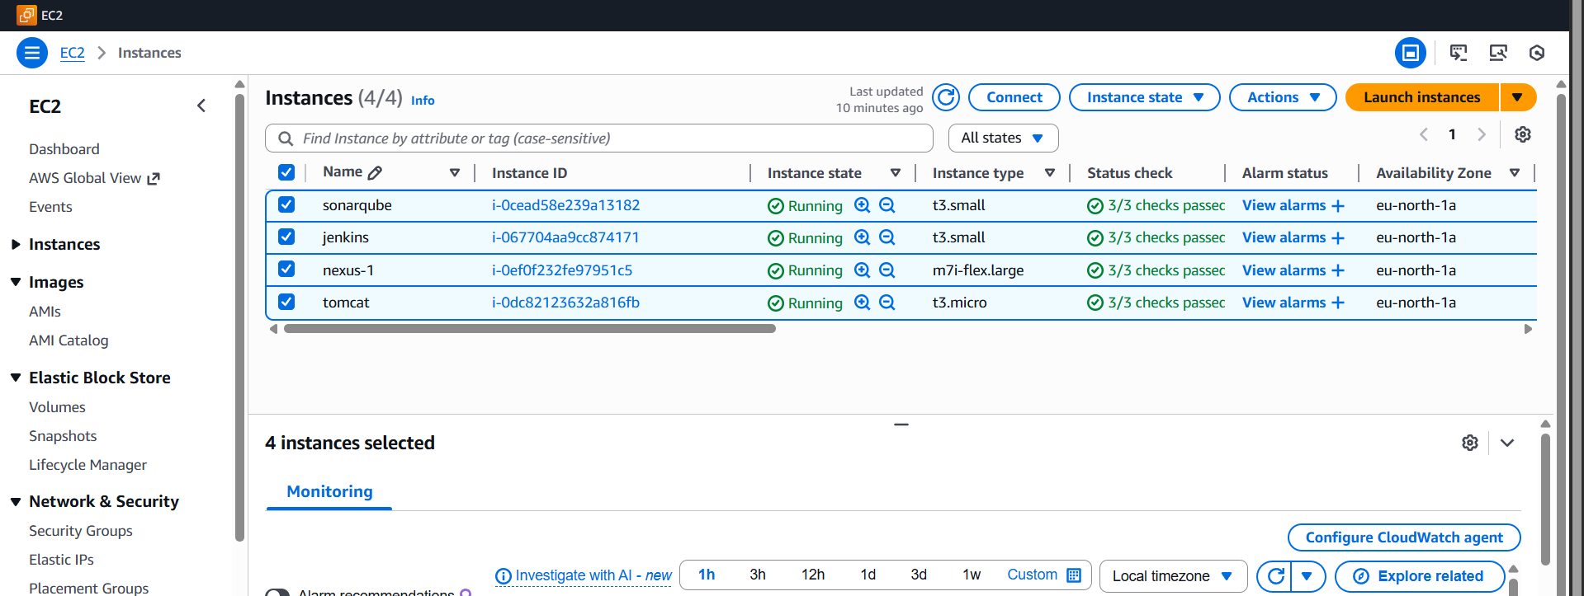open the Jenkins, and create a Jenkins project
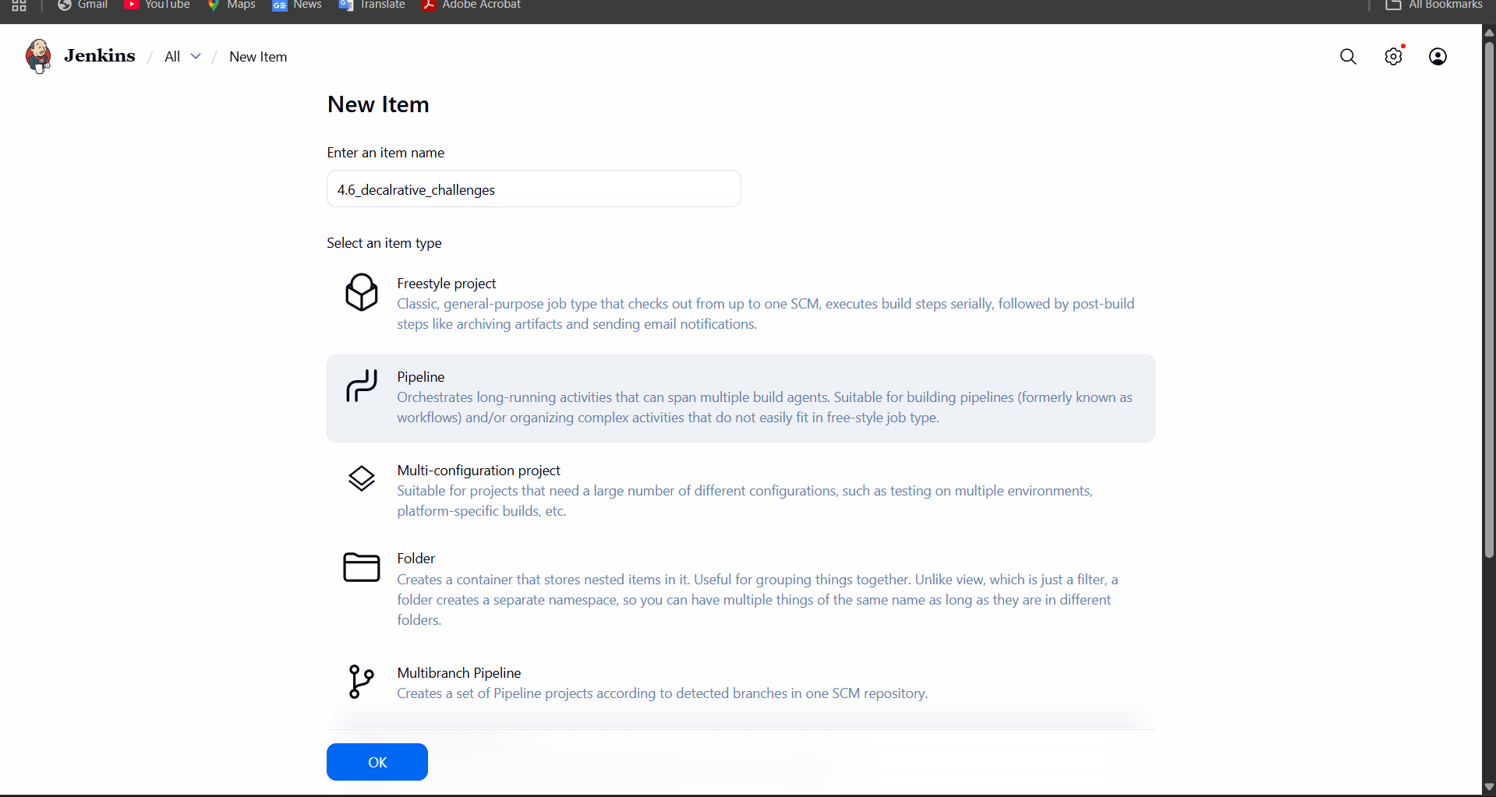
First git clone https://github.com/betawins/hiring-app.git
use this link and do
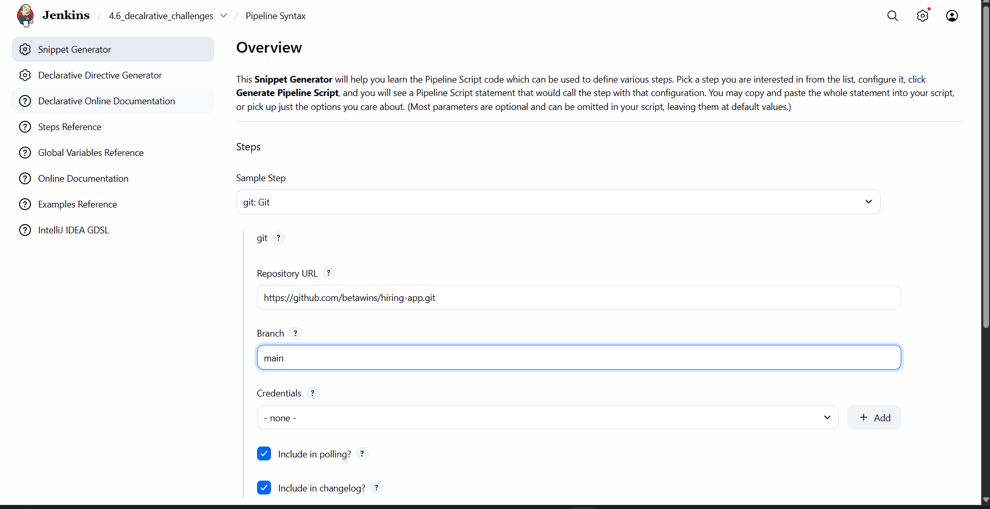
Give first which details need then. later, generate the script after we have some line script
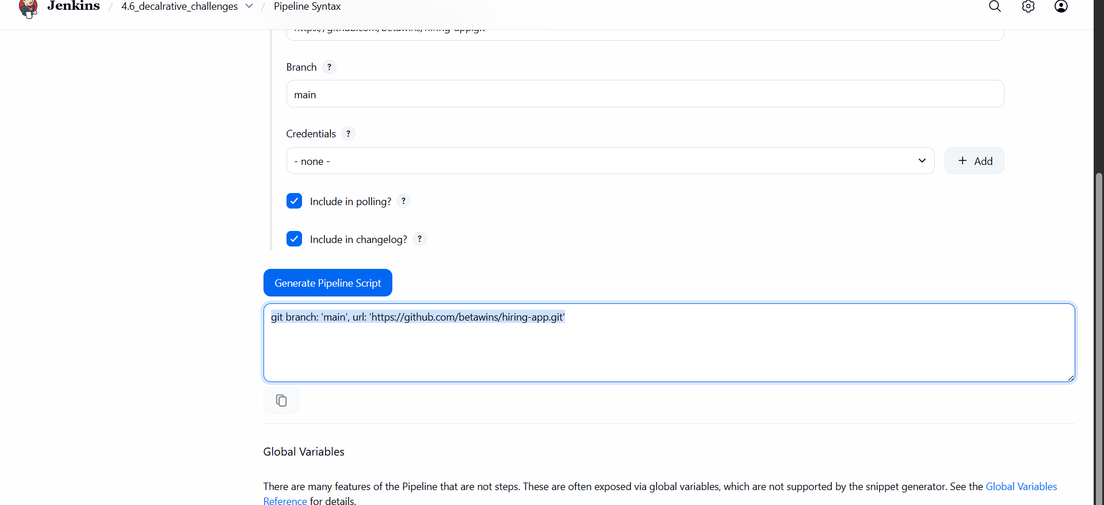
Some details need to be modified there
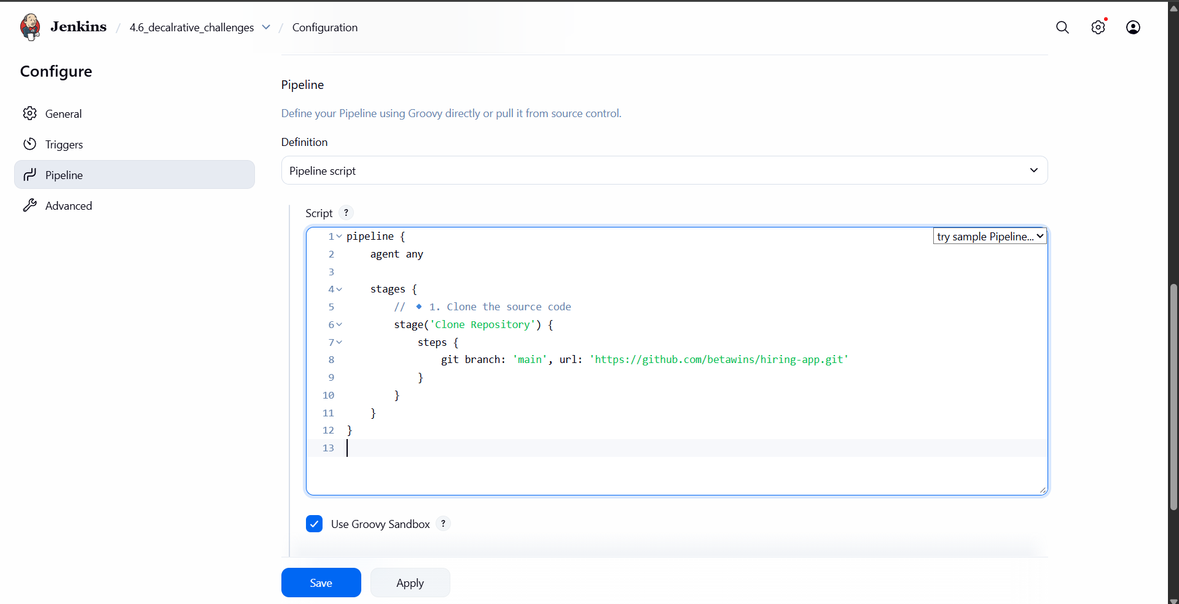
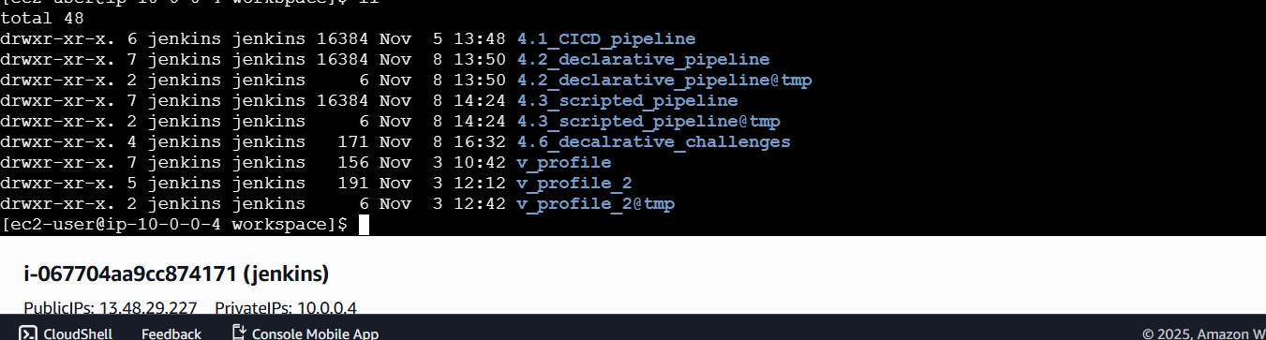
Once execute the git clone, our source code will be downloaded to the local repository
Step 2:
sonarqube integration
Follow these steps
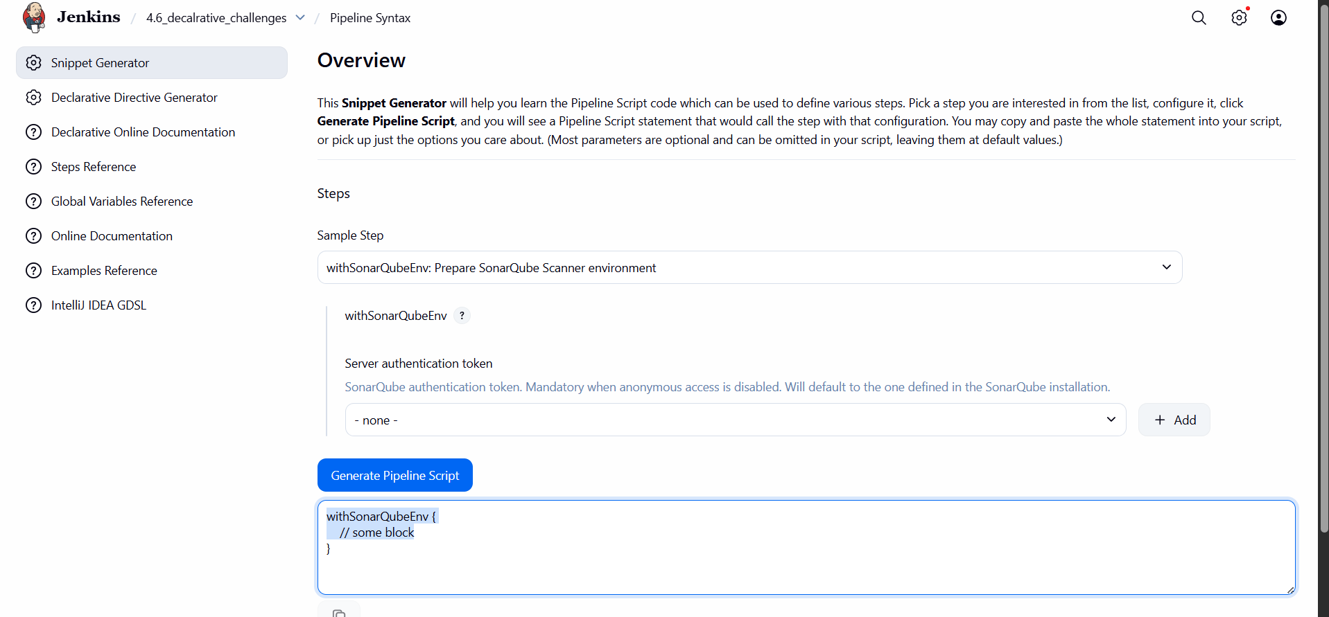
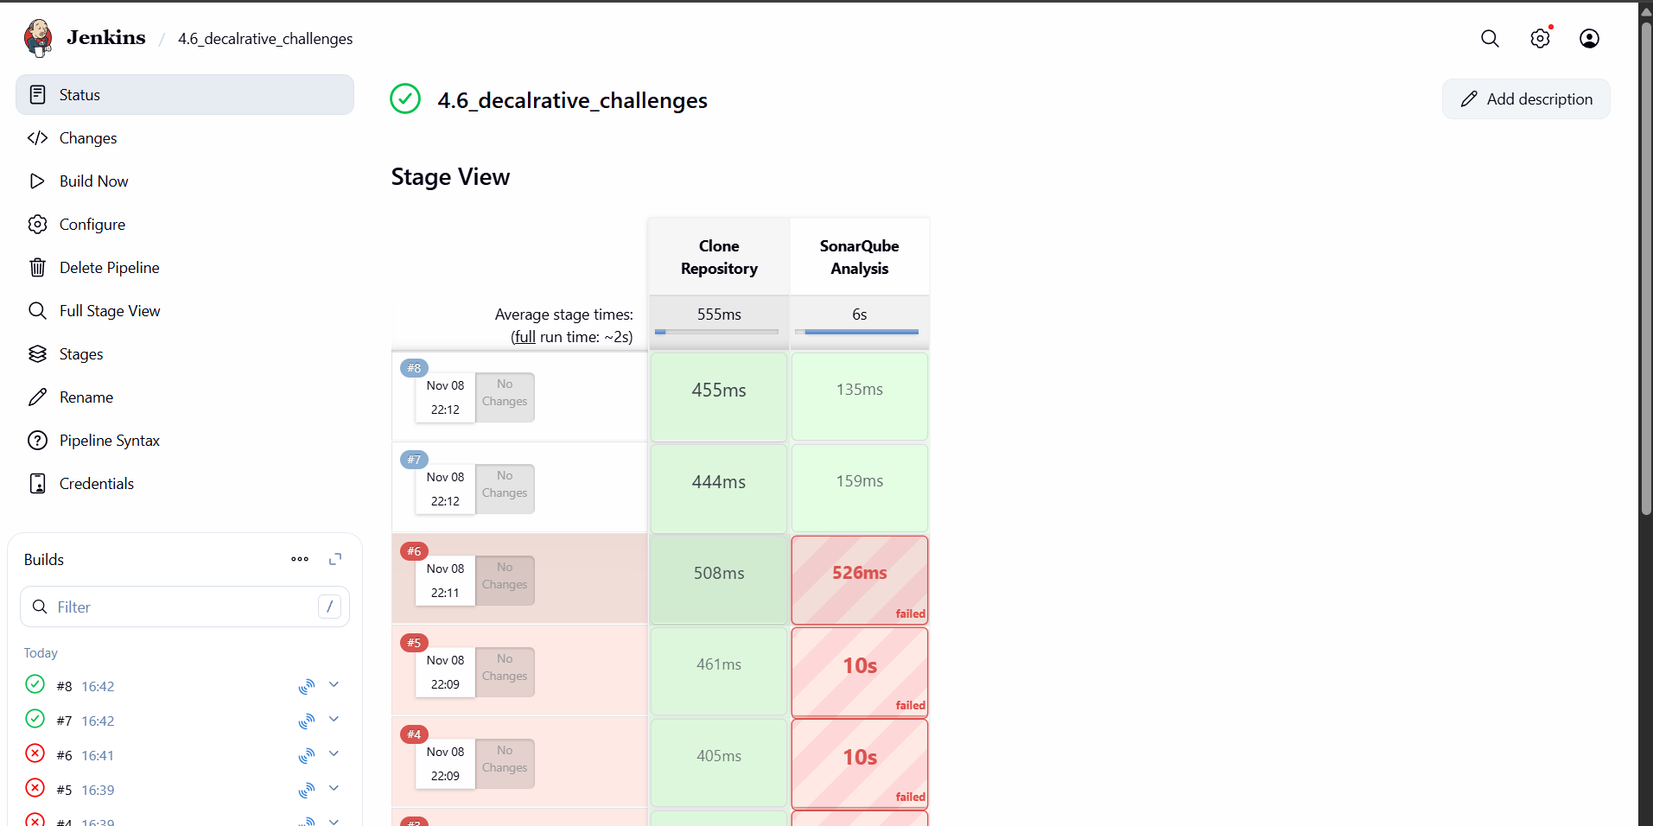
I
Stage | Purpose
Clone Repository | Pulls the code from GitHub (main branch).
Maven Build | Runs a full clean and compile + package the app.
SonarQube Analysis | Performs static code analysis on the built source code.
tools { maven 'MVN_HOME' } | Automatically sets up Maven using Jenkins’ managed installation.
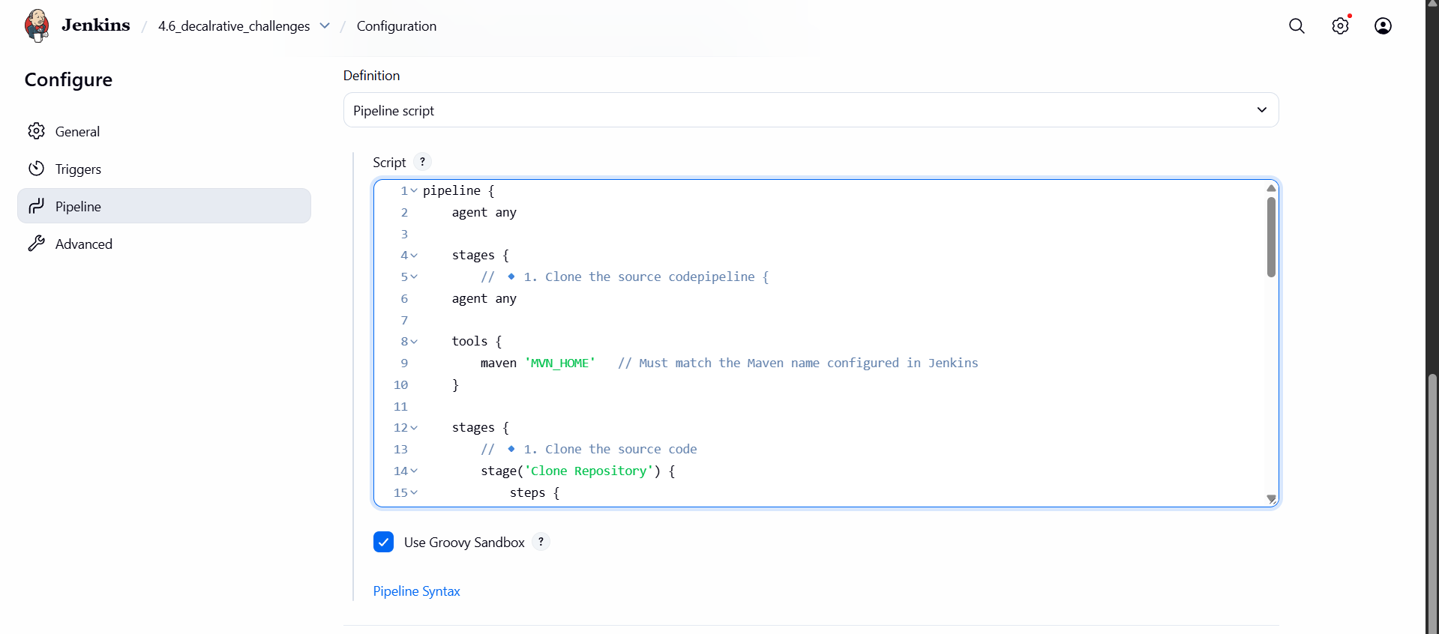
Now maven add code these line 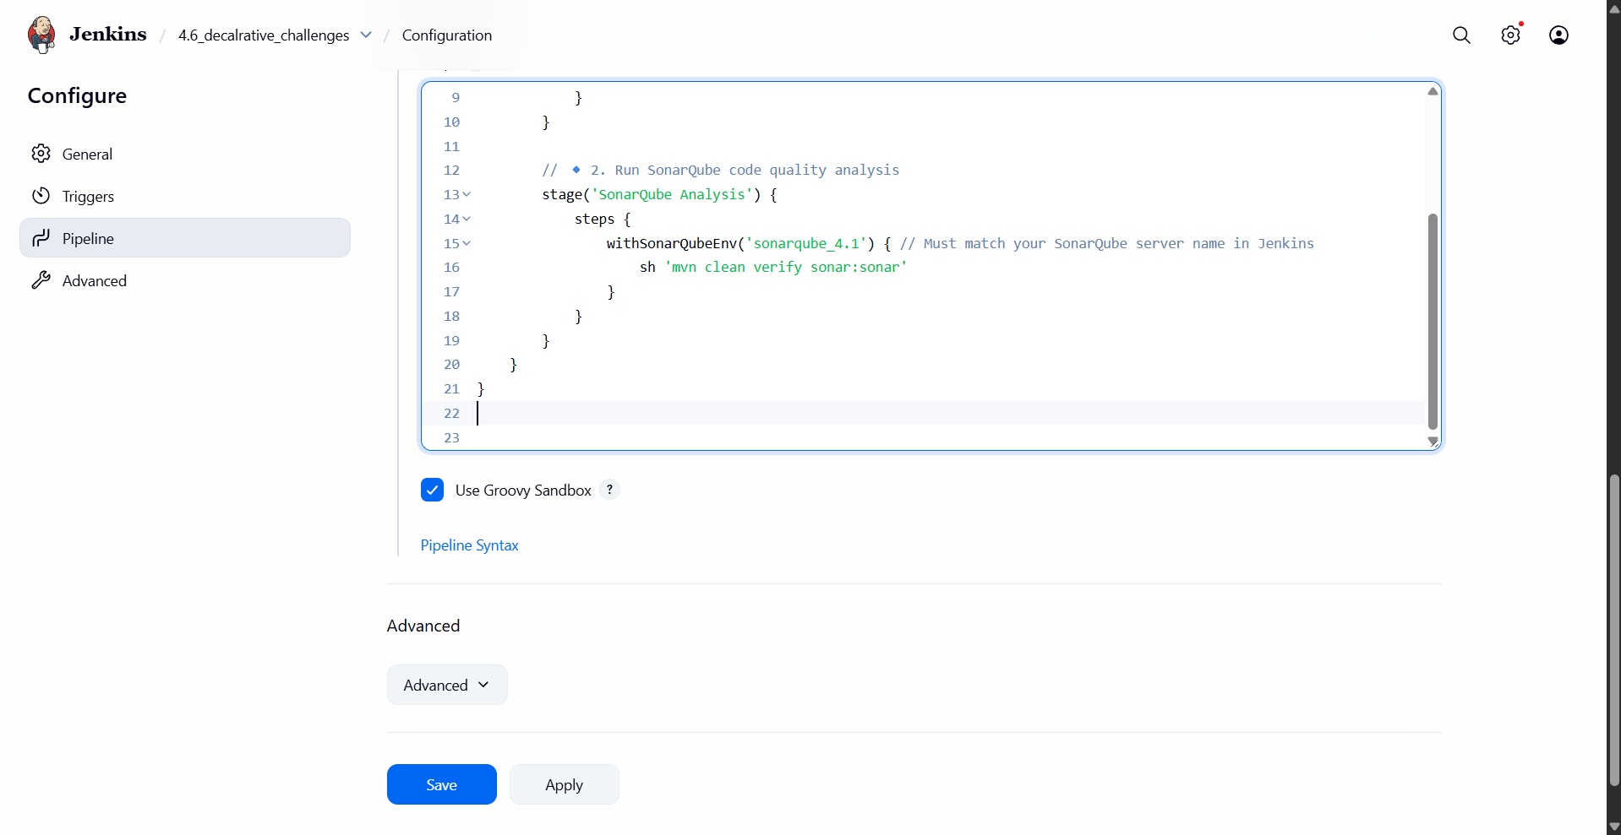
And this line also
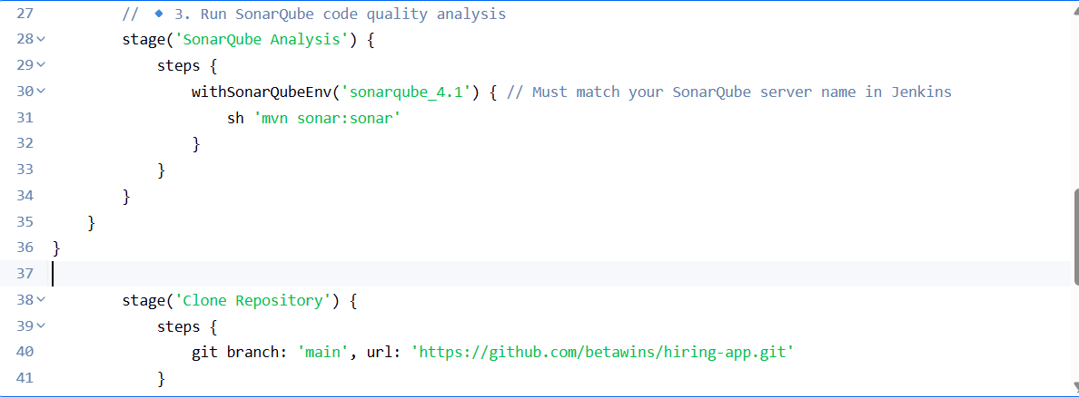

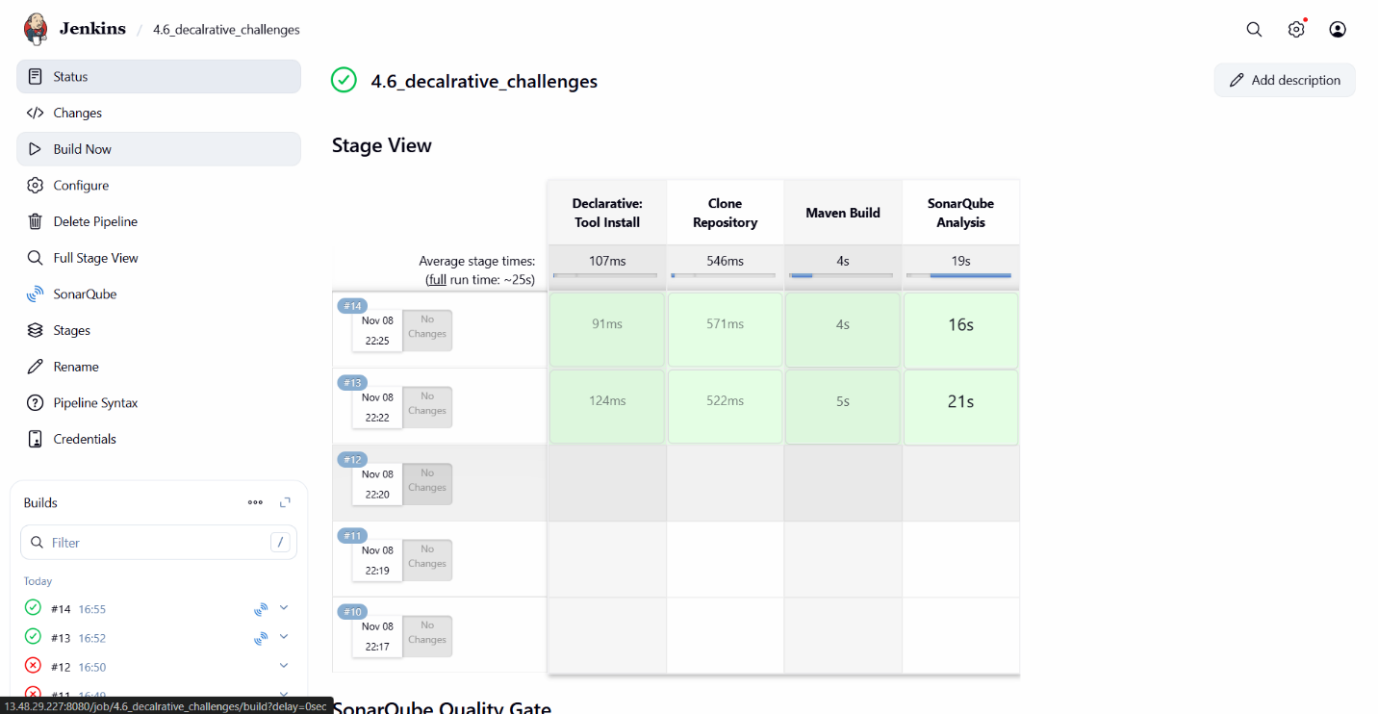
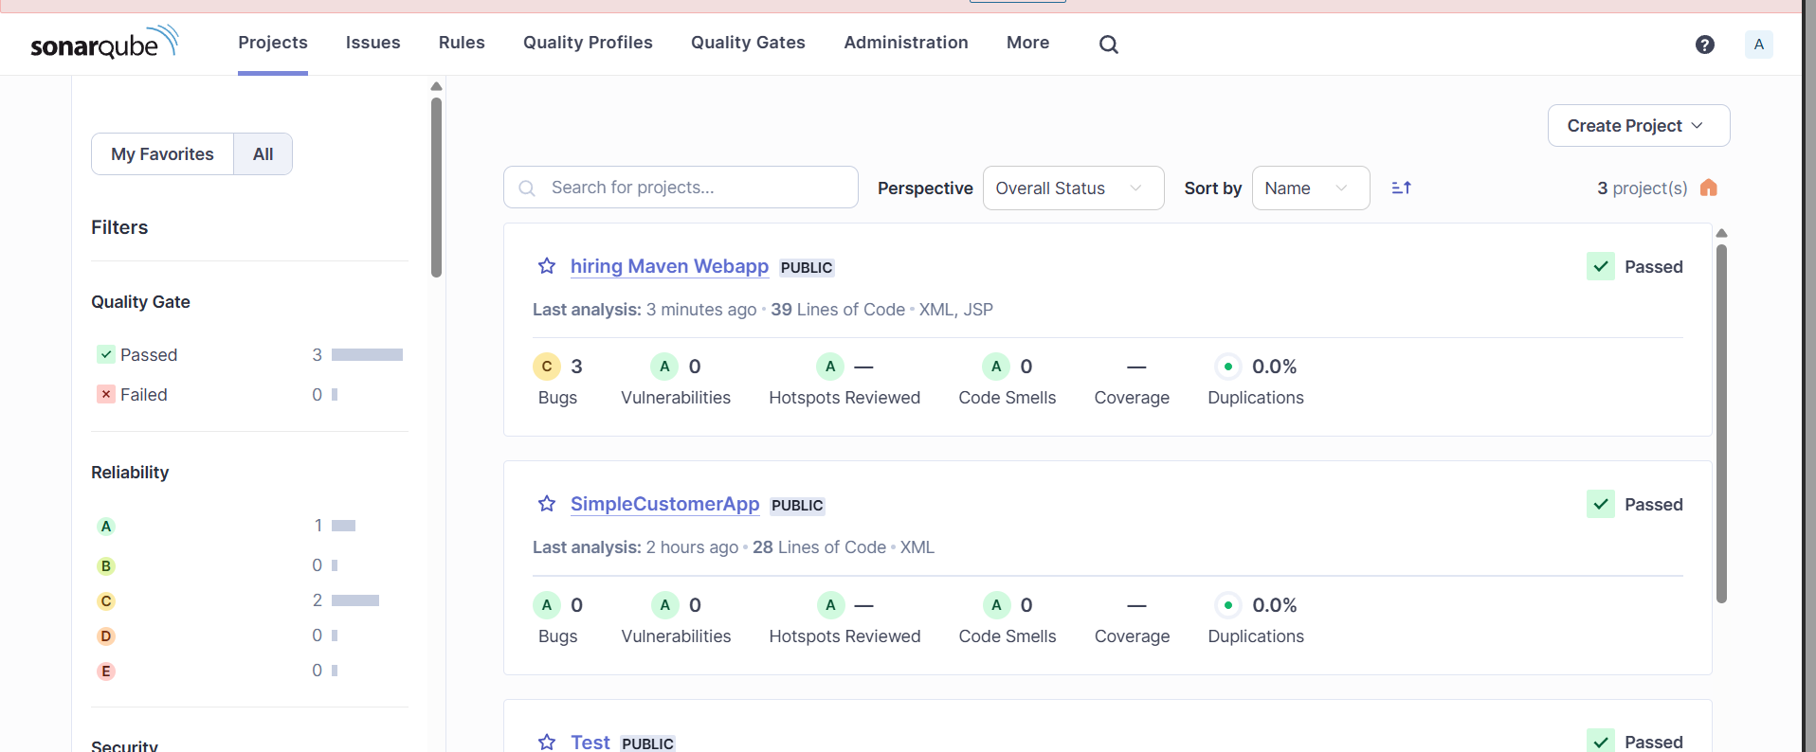
now see SonarQube integration happen see there now
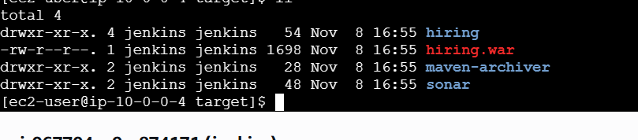
D ) nexus atricfactroy
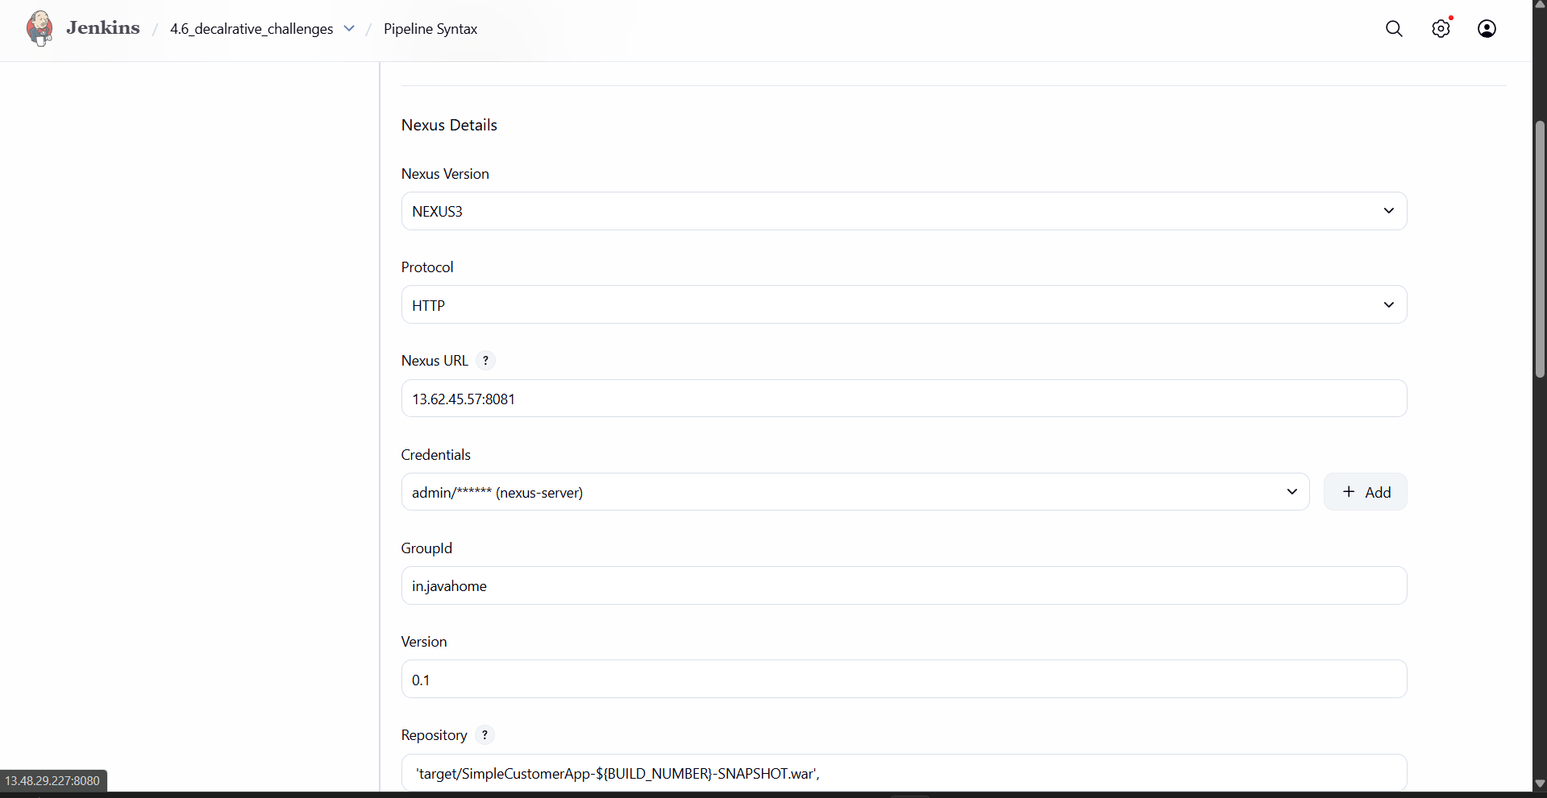
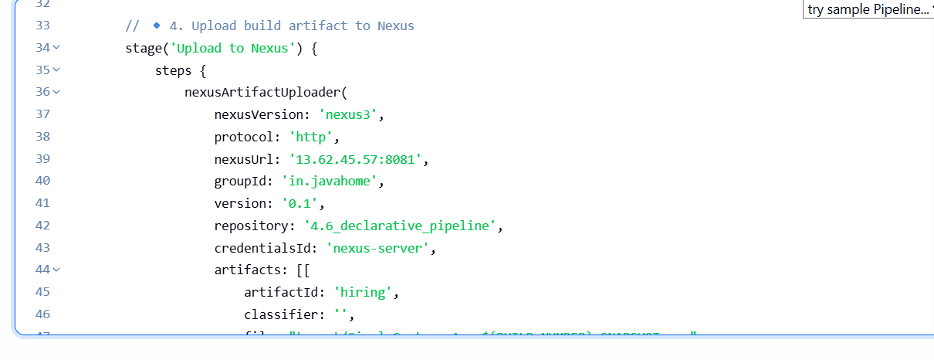
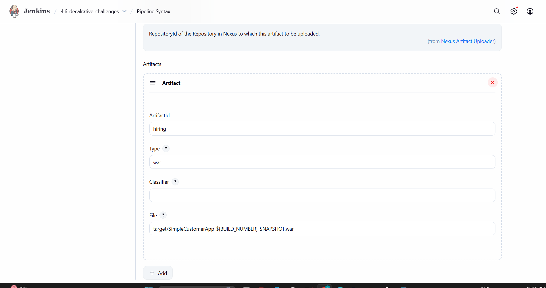
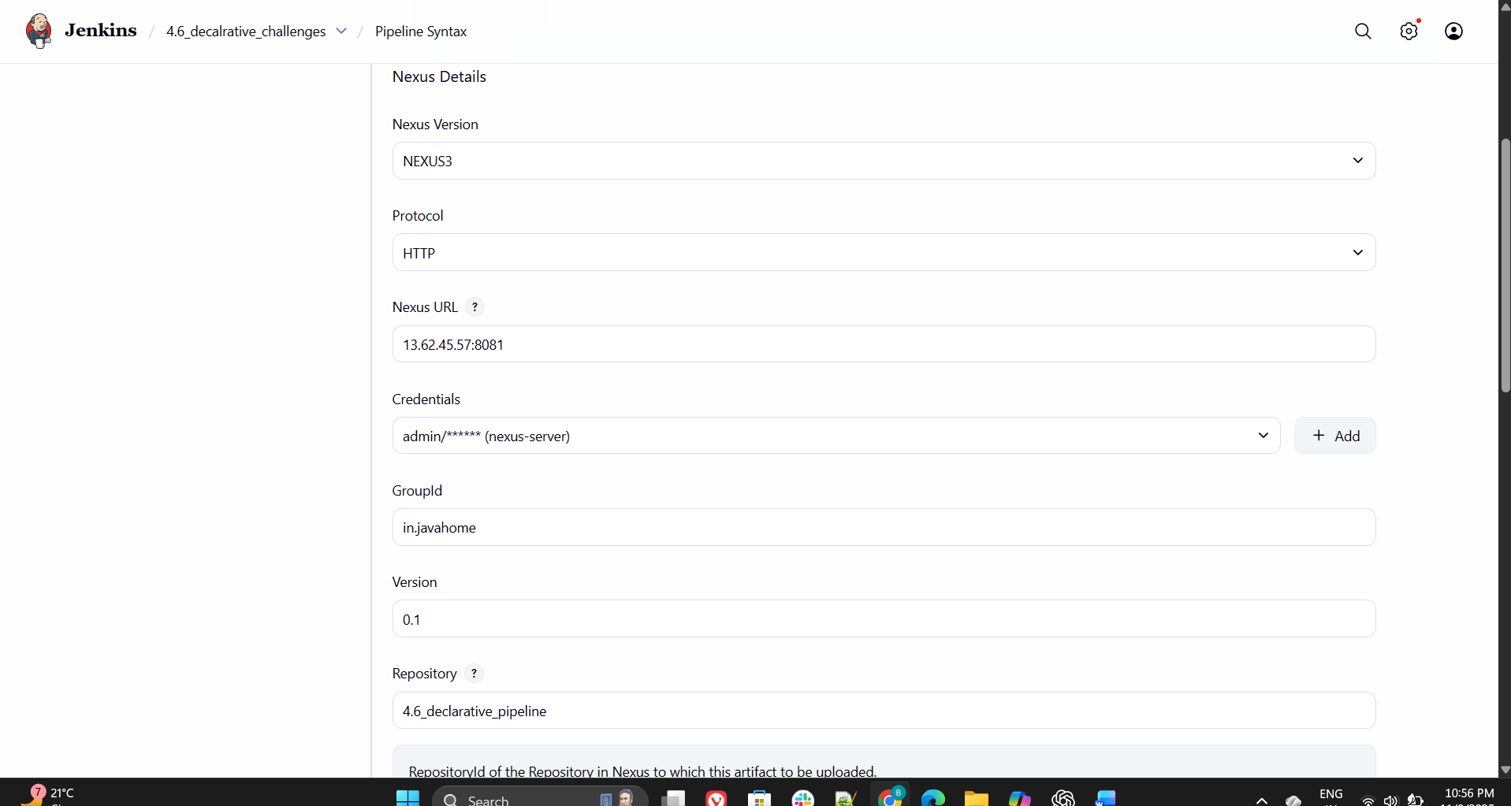
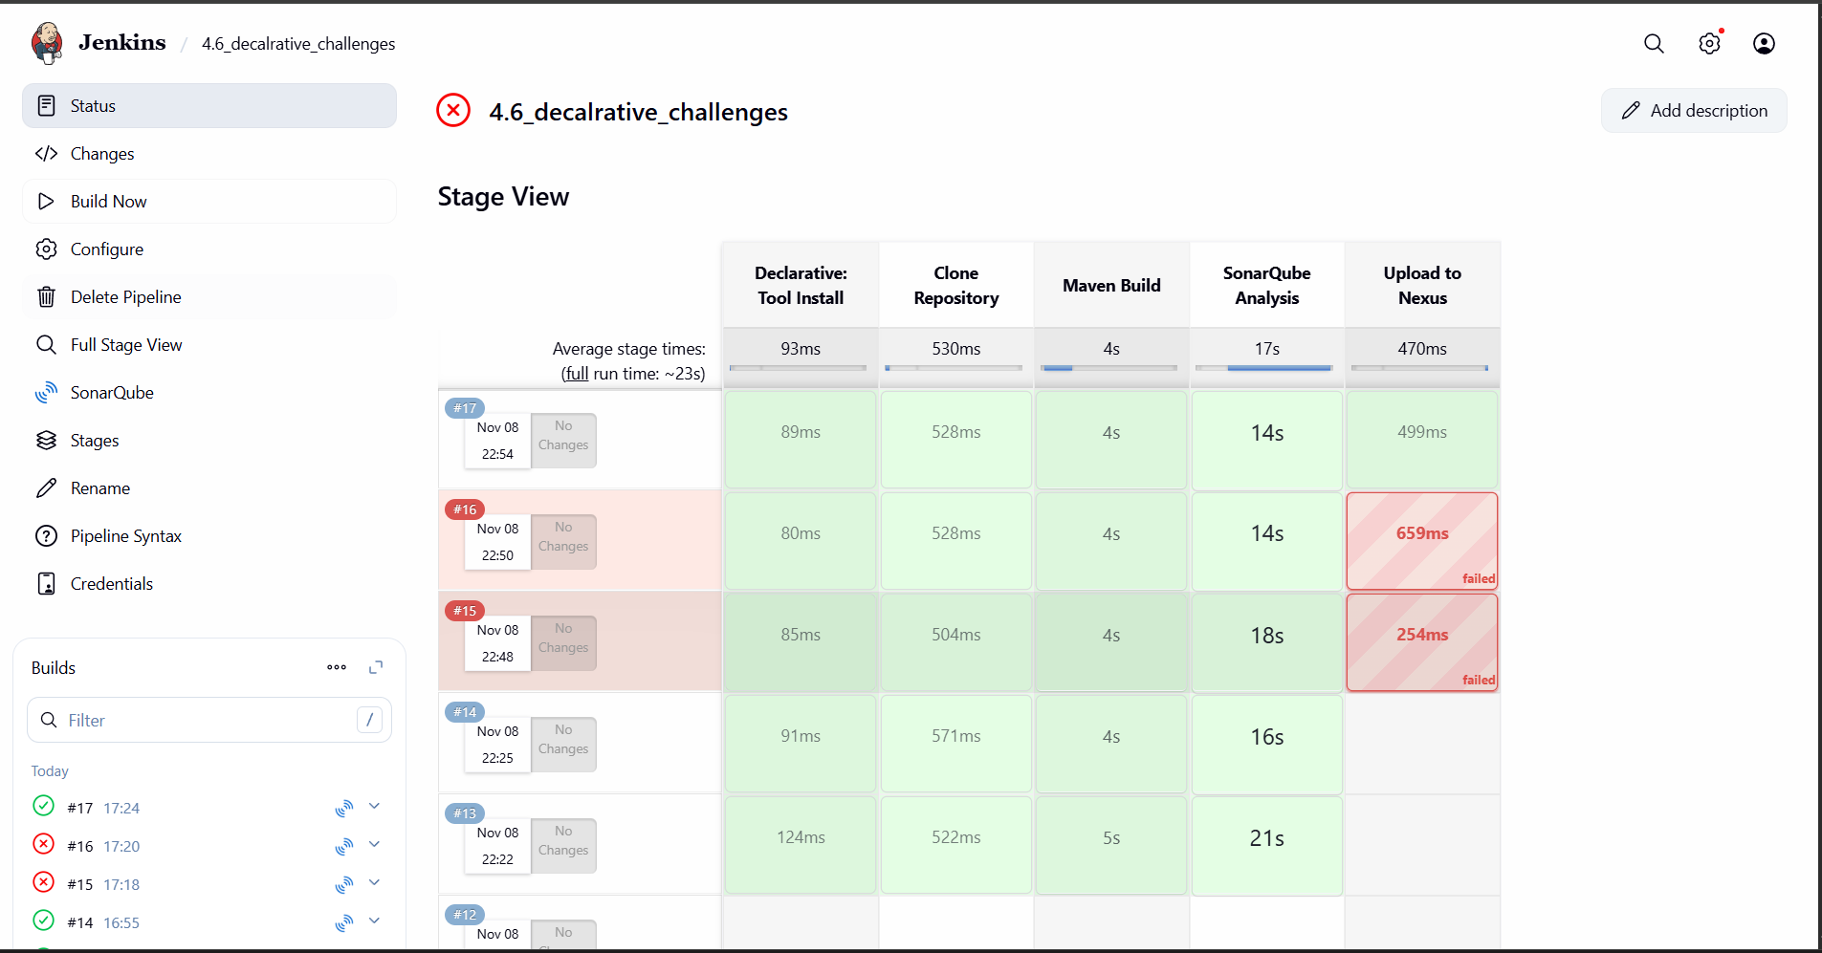
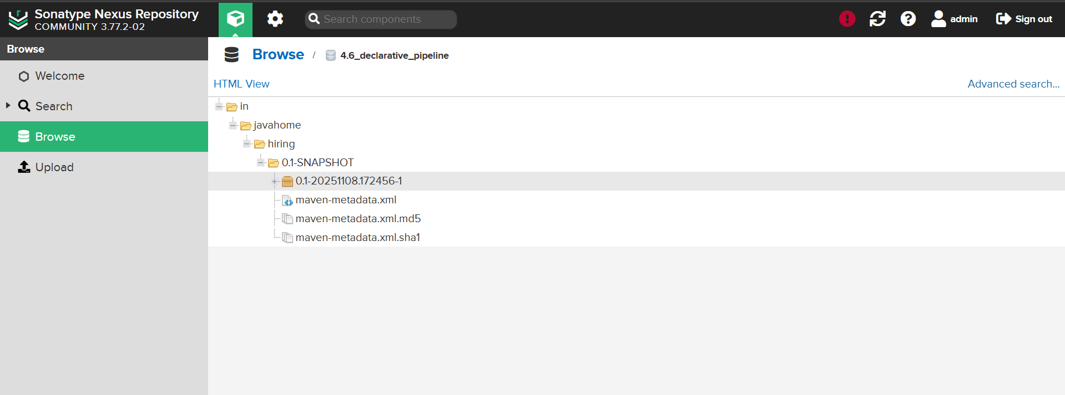
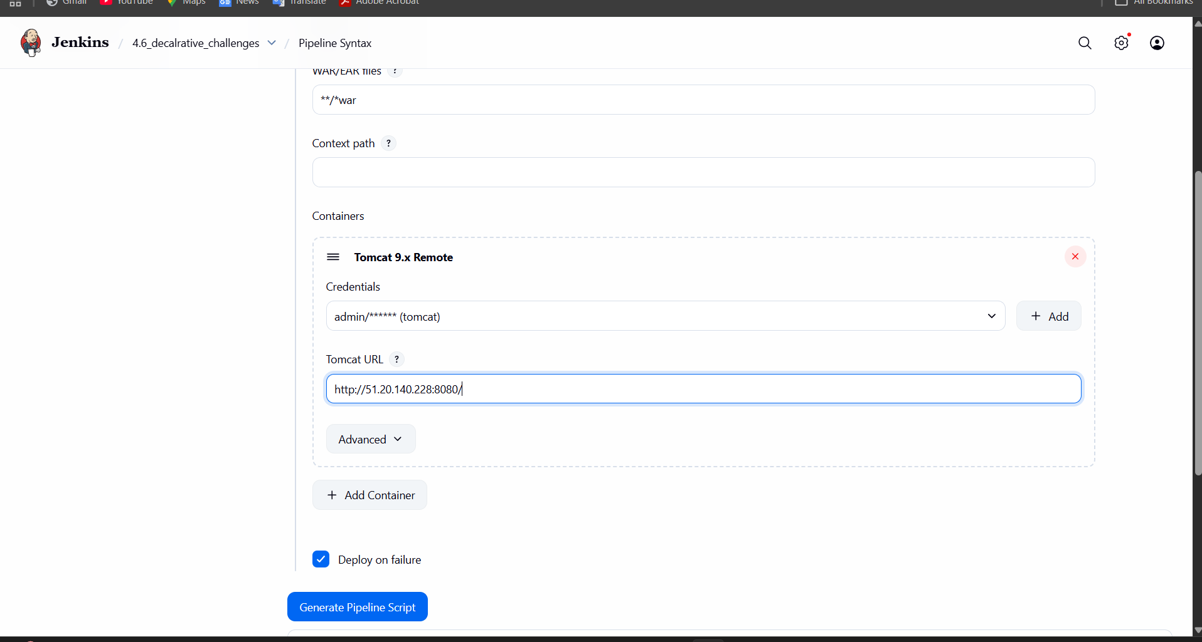
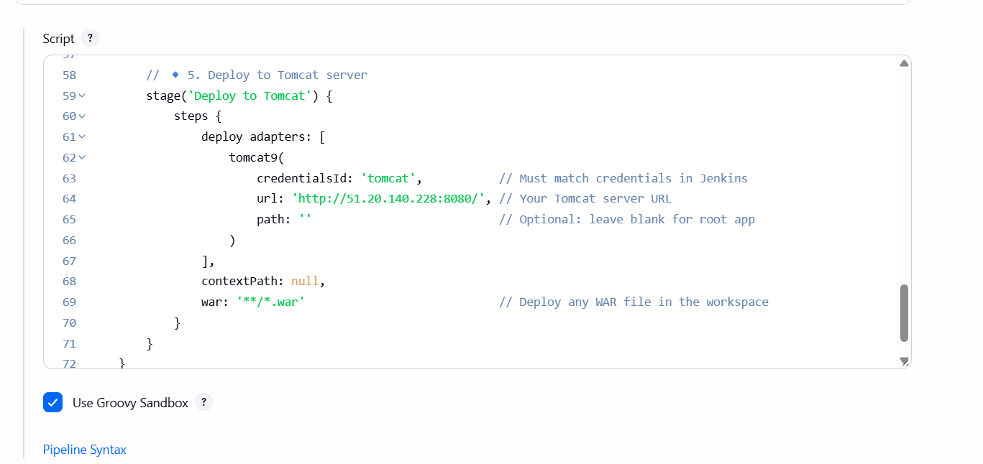
This is the code that should be executed
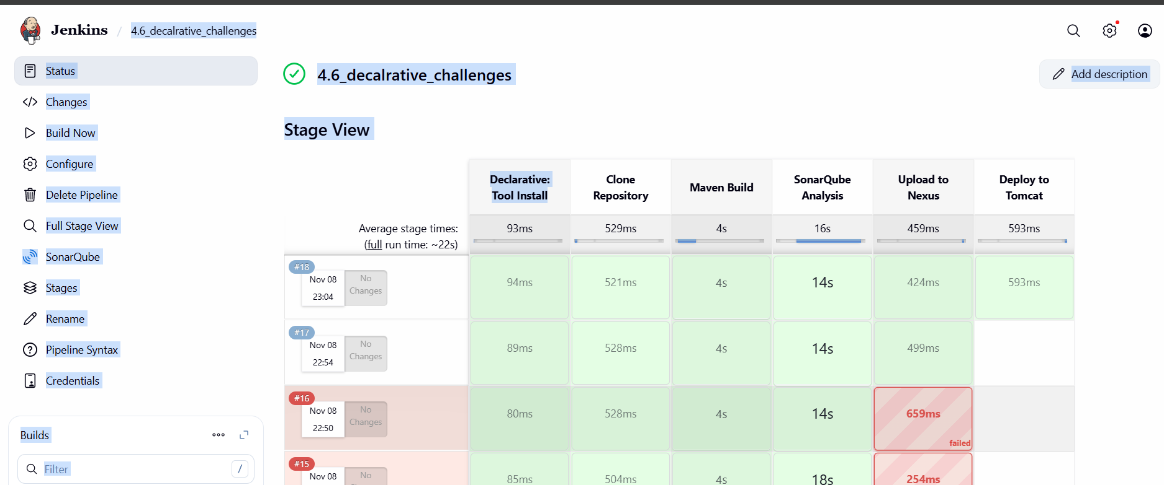
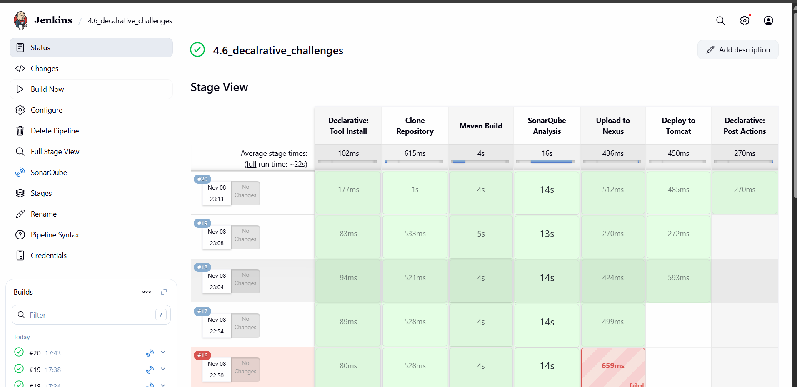
What This Pipeline Does:
- Clones the repository from GitHub.
- Builds the .war file using Maven.
- Analyzes code quality with SonarQube.
- Uploads the build artifact to Nexus.
- Deploys the WAR file to Tomcat.
- Sends Slack notifications at every stage and final status.

- Create one Declarative pipeline job
- Create one Scripted pipeline job
- Create one multistage pipeline job
- Create one parallel stage pipeline job

  - Create one Scripted pipeline job
We need an open, sufficient instance for which we should open
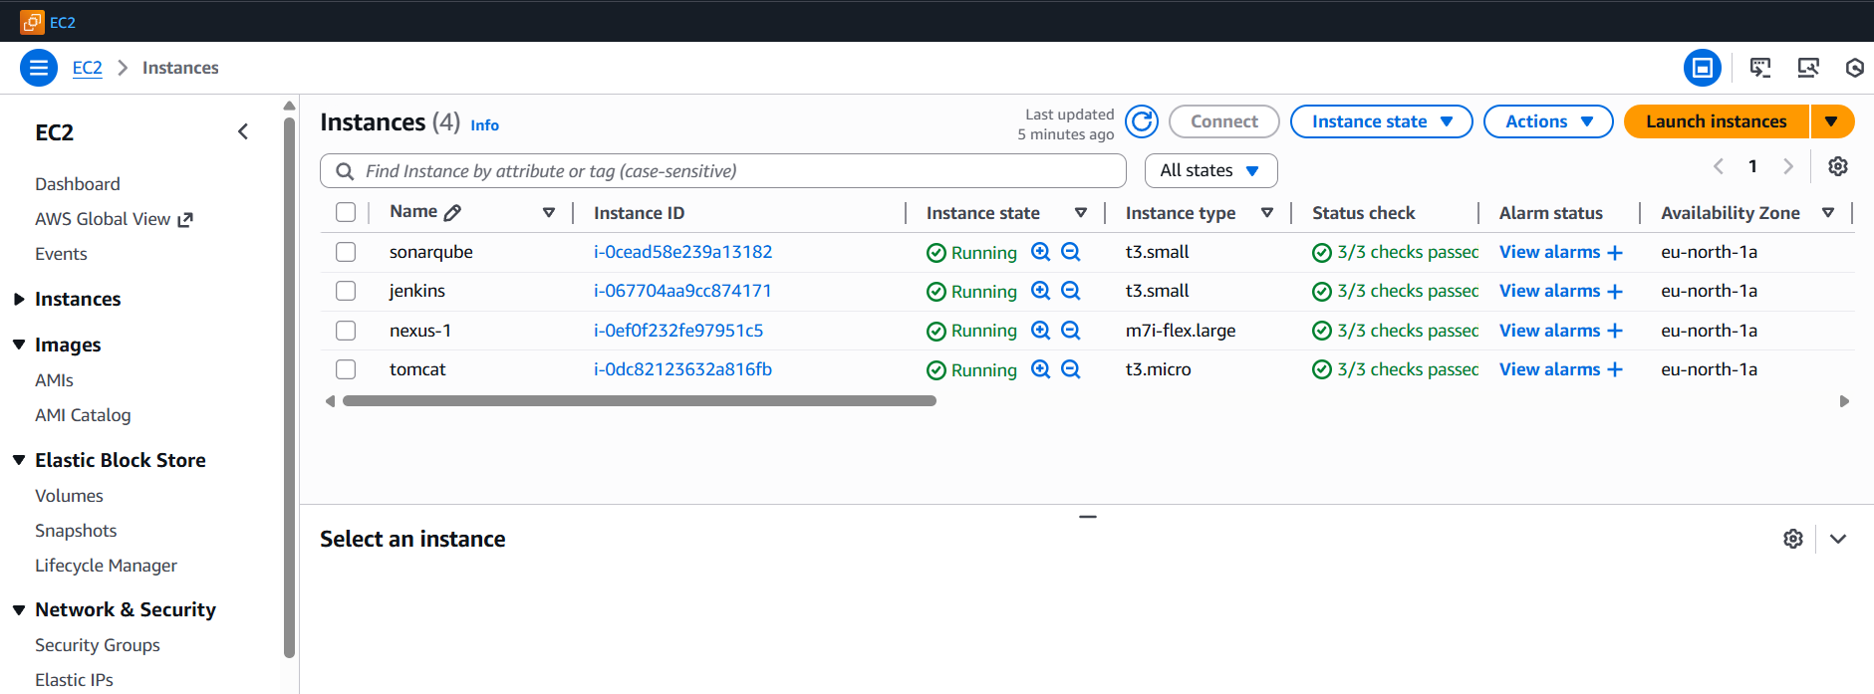
Start to open new scripted pipeline
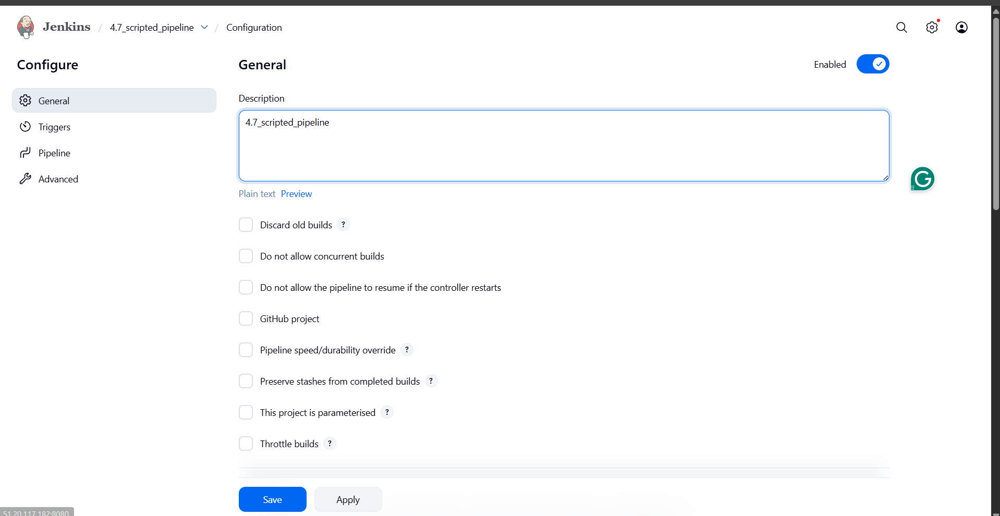
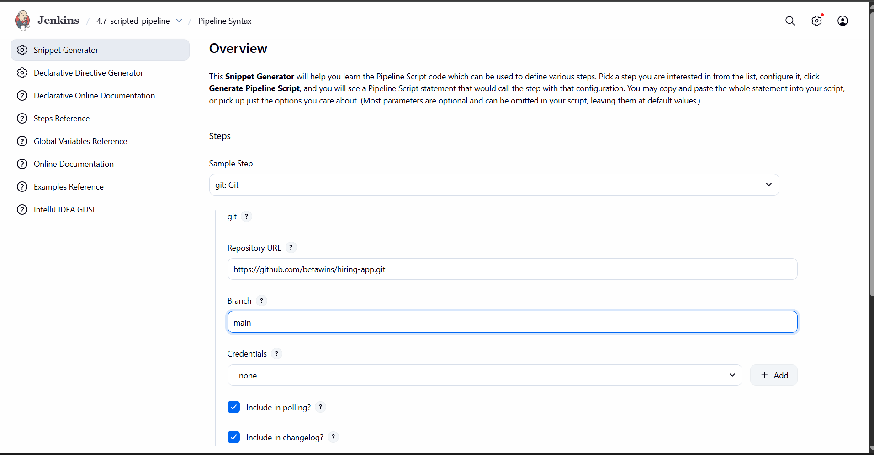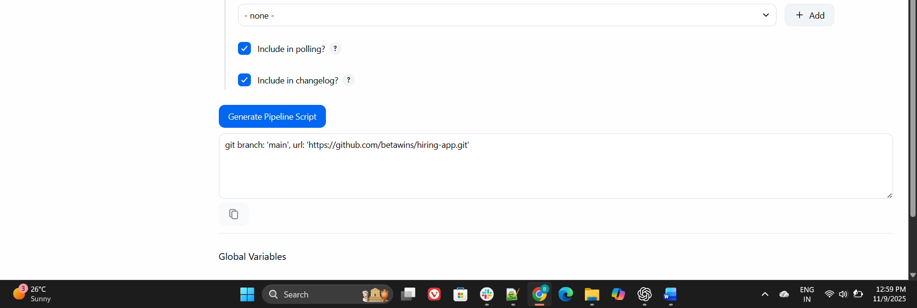
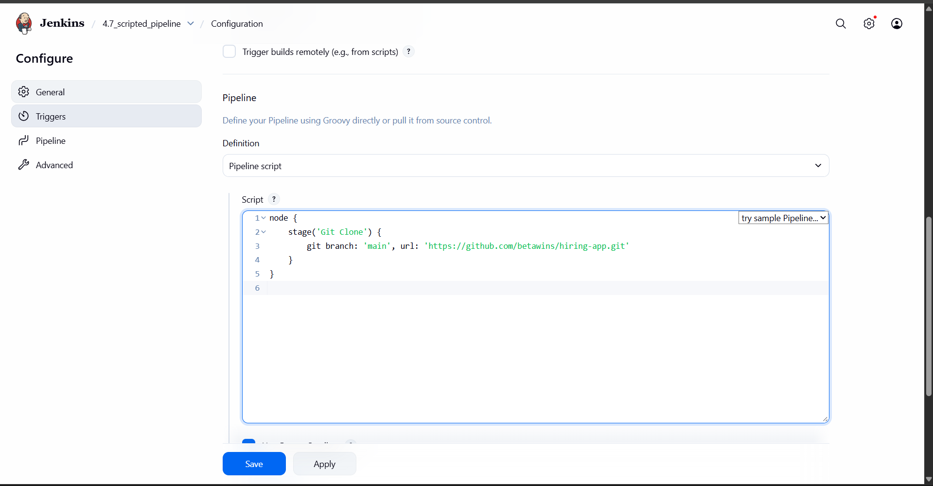
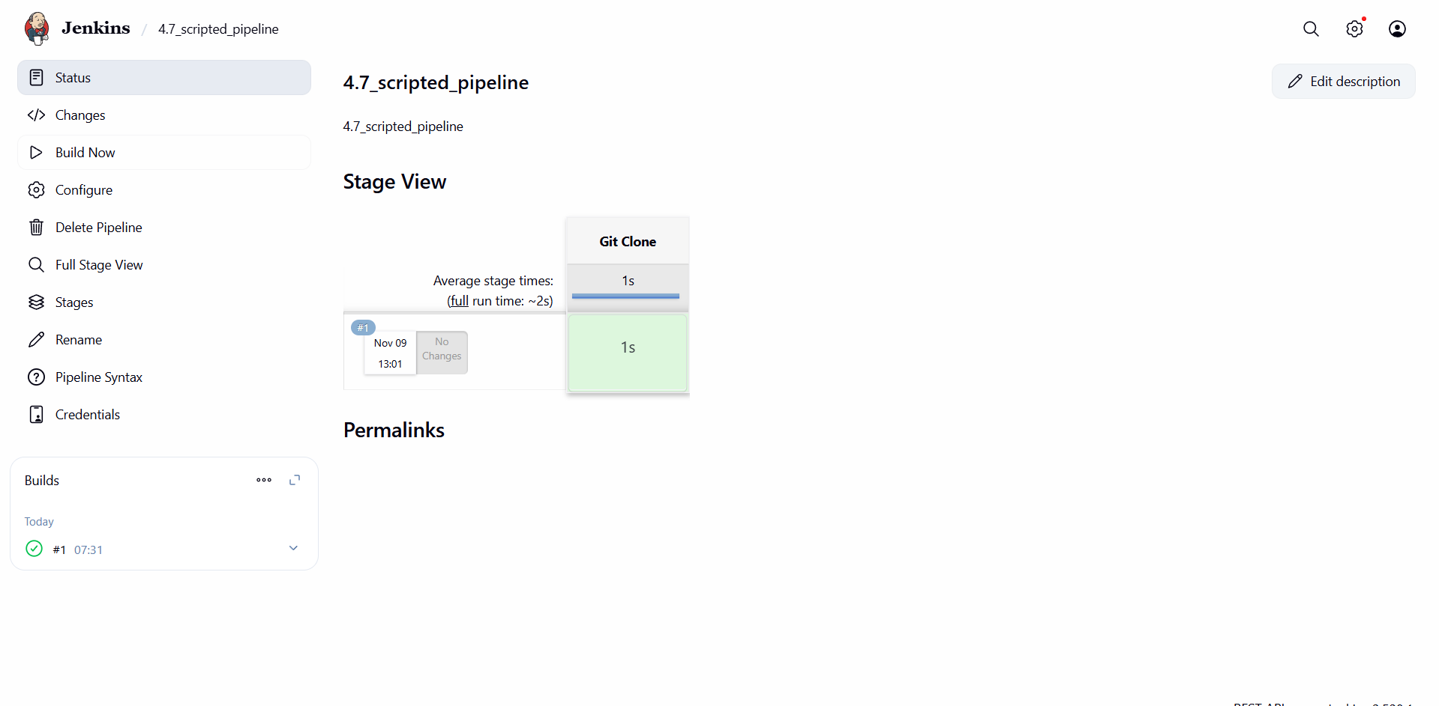
Now we can see the output that the git is clone successful
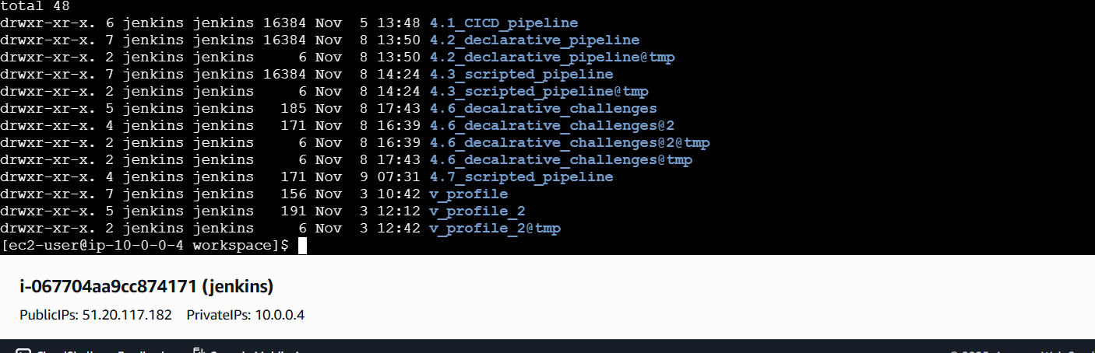
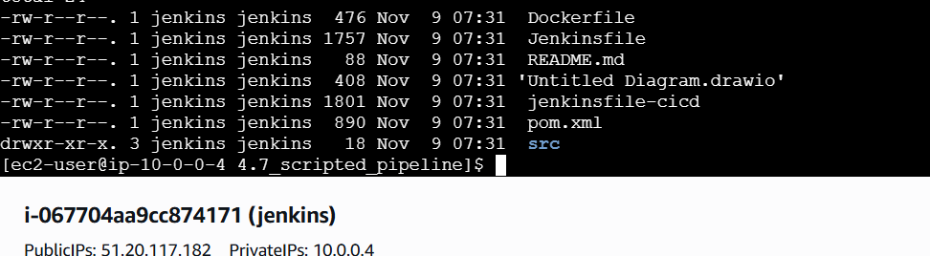
1 Git Clone
2 SonarQube Analysis

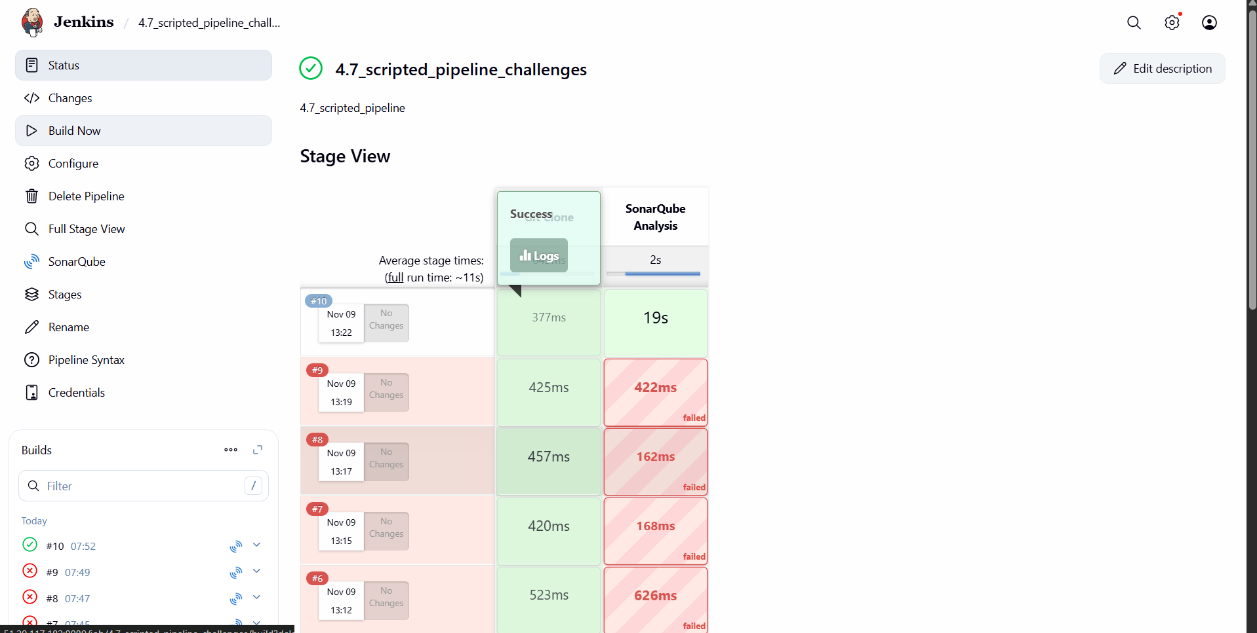

Each task should have its own stage (Git Clone, Maven Build, SonarQube Analysis)
✅ Using Maven for both build and SonarQube scan
✅ Simple, clean Scripted Pipeline

node {
// Load Maven tool configured in Jenkins
def mvnHome = tool name: 'MVN_HOME', type: 'maven'

stage('Git Clone') {
echo "📥 Cloning the repository..."
git branch: 'main', url: 'https://github.com/betawins/hiring-app.git'
}

stage('Maven Build') {
echo "⚙️ Running Maven Build..."
sh "${mvnHome}/bin/mvn clean package -f pom.xml"
}

stage('SonarQube Analysis') {
echo "🔍 Running SonarQube Analysis..."
withSonarQubeEnv('sonarqube_4.1') { // Must match Jenkins SonarQube configuration name
sh "${mvnHome}/bin/mvn sonar:sonar -f pom.xml"
}
}
}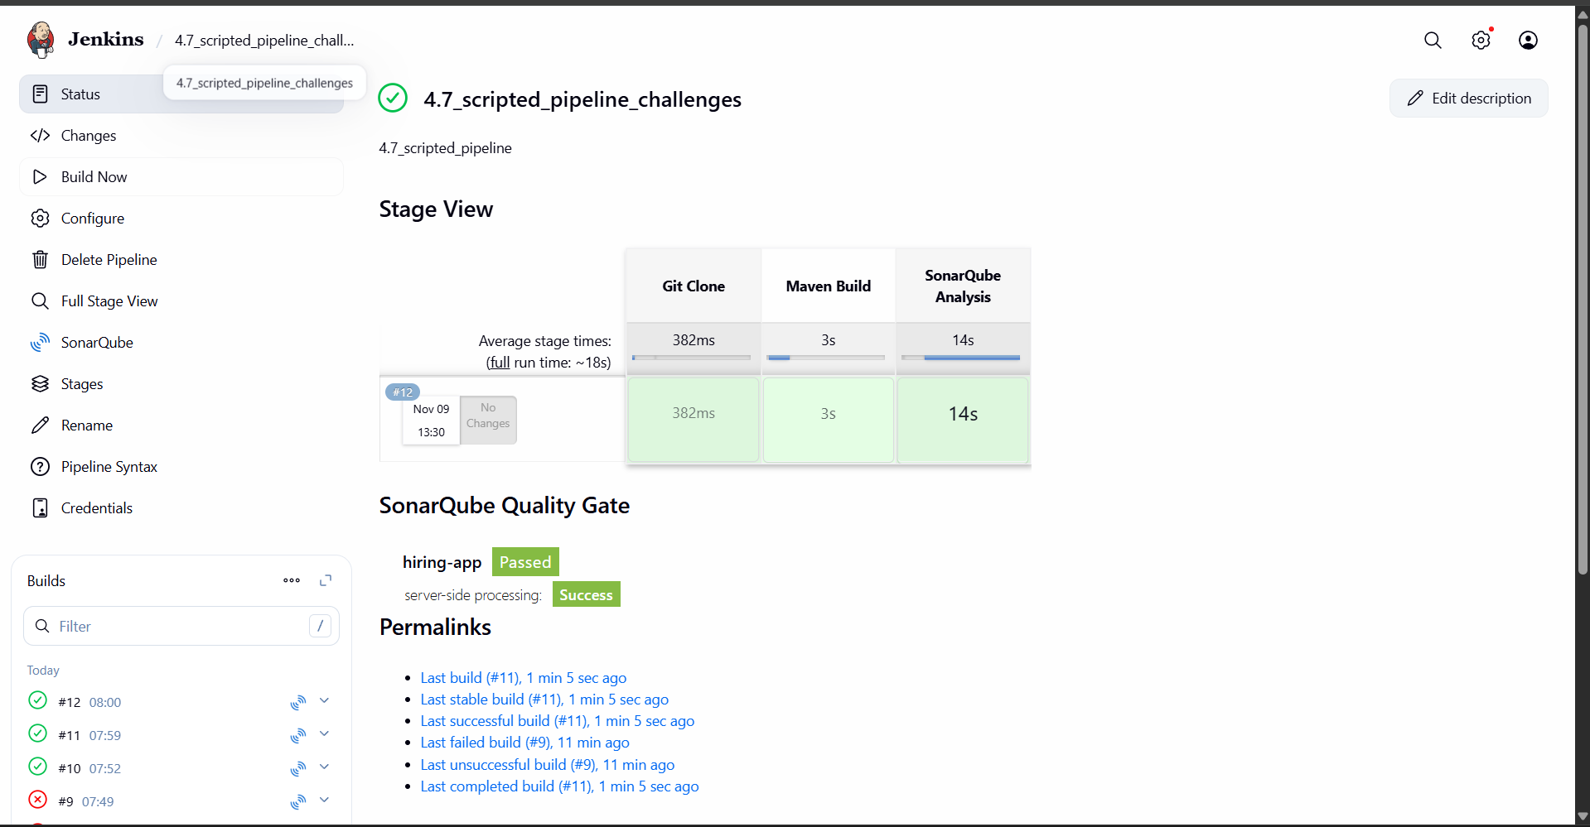
Maven see there
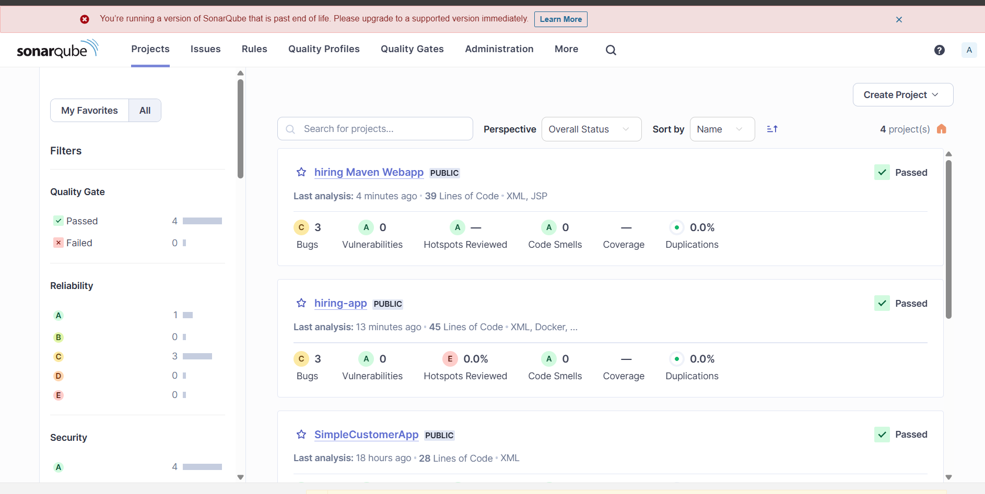
1️⃣ Git Clone
2️⃣ Maven Build
3️⃣ SonarQube Analysis
4️⃣ Nexus Artifact Upload

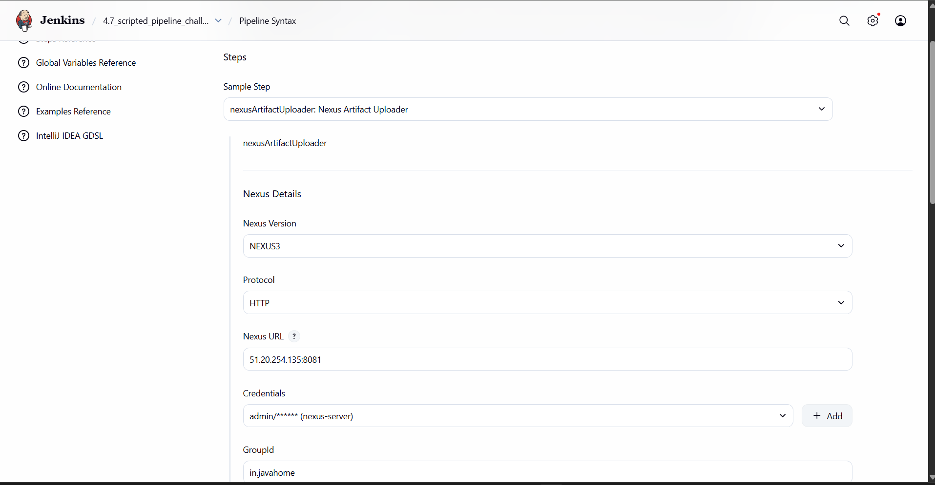
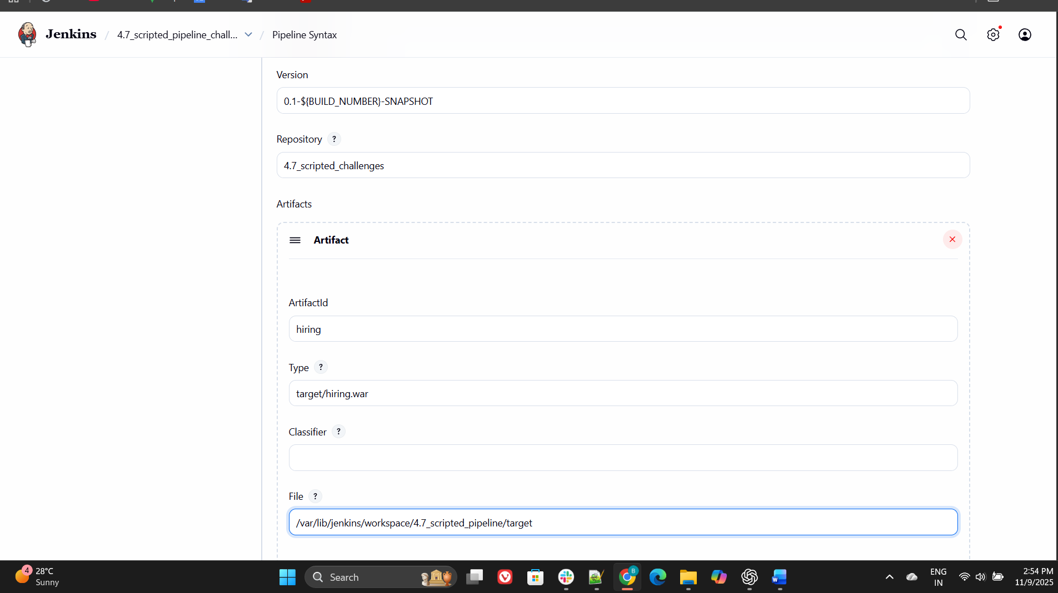
nexusArtifactUploader artifacts: [[artifactId: 'hiring', classifier: '', file: '/var/lib/jenkins/workspace/4.7_scripted_pipeline/target', type: 'target/hiring.war']], credentialsId: 'nexus-server', groupId: 'in.javahome', nexusUrl: '51.20.254.135:8081', nexusVersion: 'nexus3', protocol: 'http', repository: '4.7_scripted_challenges', version: '0.1-${BUILD_NUMBER}-SNAPSHOT'
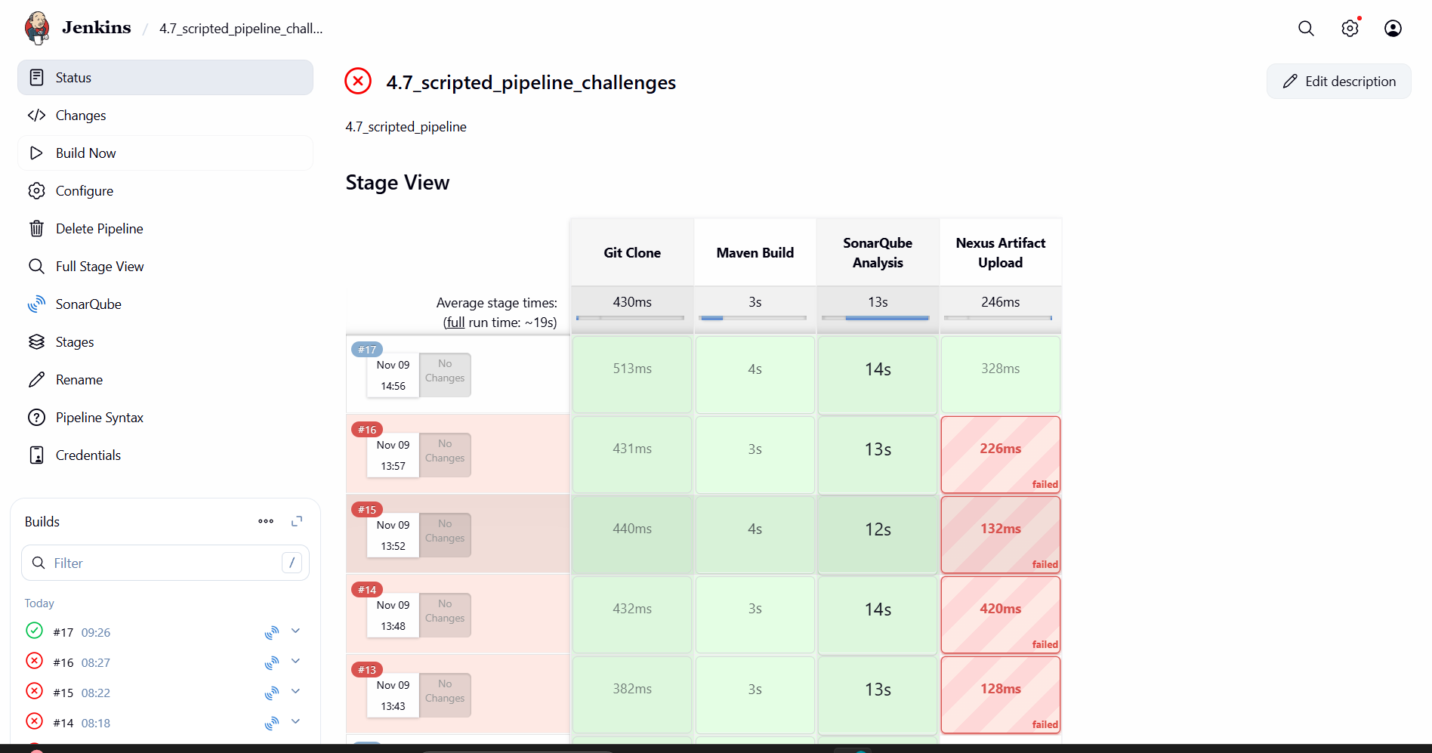
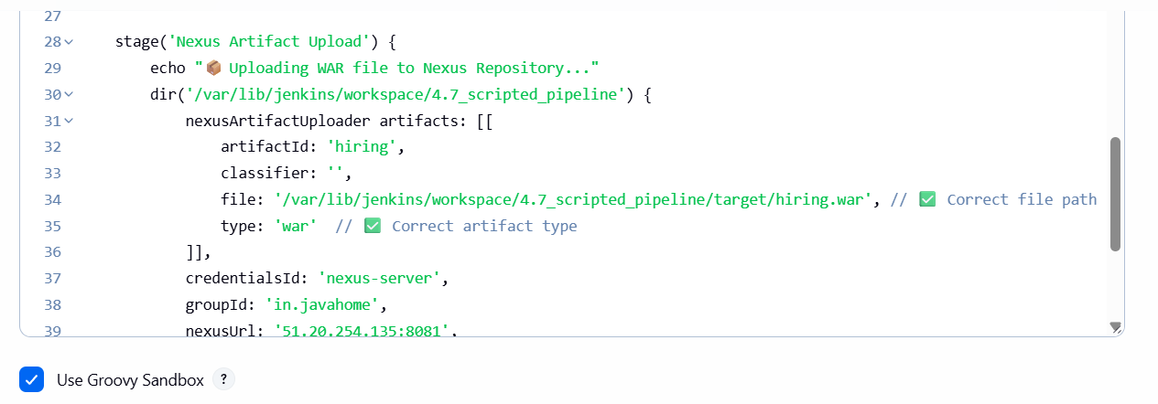
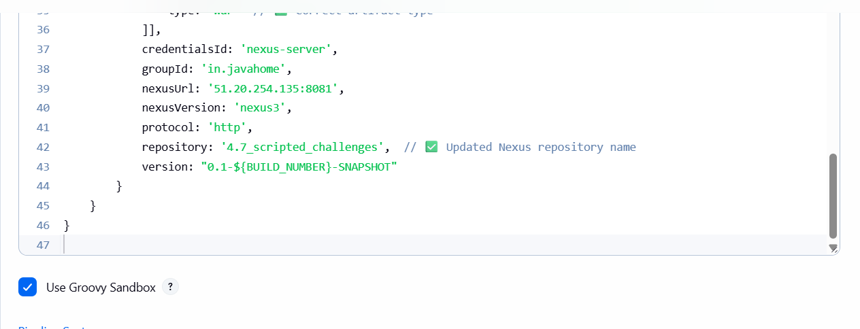
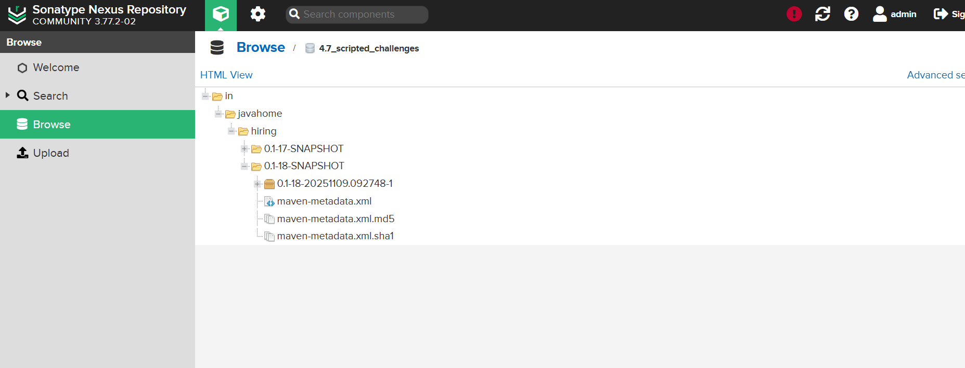
This is the code we had executed

Tomcat deploy
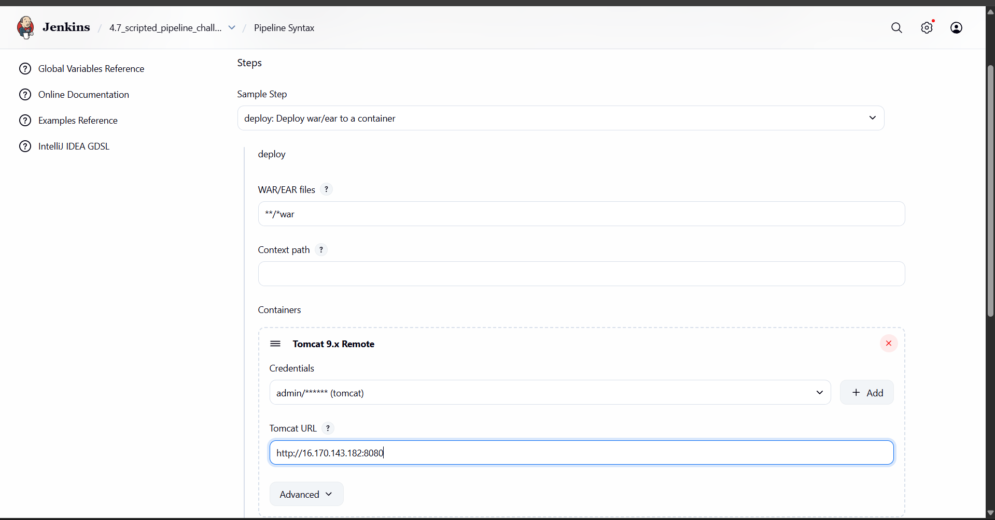
deploy adapters: [tomcat9(alternativeDeploymentContext: '', credentialsId: 'tomcat', path: '', url: 'http://16.170.143.182:8080')], contextPath: null, war: '**/*war'
This is the code that we got
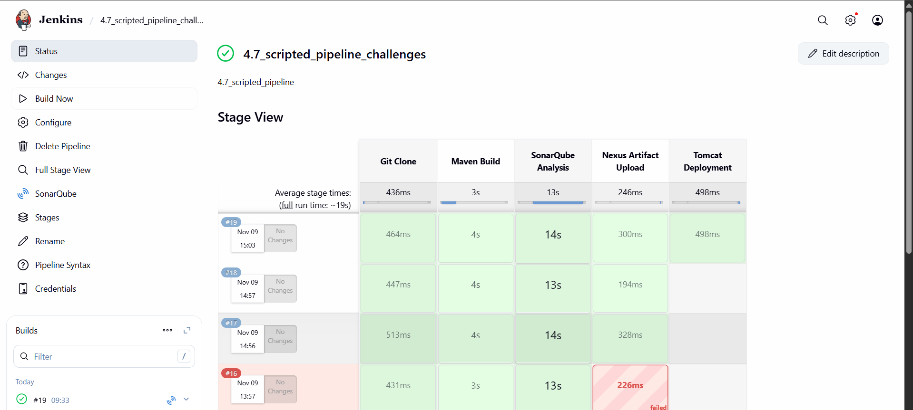
node {
// Load Maven tool configured in Jenkins
def mvnHome = tool name: 'MVN_HOME', type: 'maven'

stage('Git Clone') {
echo "📥 Cloning the repository..."
dir('/var/lib/jenkins/workspace/4.7_scripted_pipeline') {
git branch: 'main', url: 'https://github.com/betawins/hiring-app.git'
}
}

stage('Maven Build') {
echo "⚙️ Running Maven Build..."
dir('/var/lib/jenkins/workspace/4.7_scripted_pipeline') {
sh "${mvnHome}/bin/mvn clean package -f pom.xml"
}
}

stage('SonarQube Analysis') {
echo "🔍 Running SonarQube Analysis..."
dir('/var/lib/jenkins/workspace/4.7_scripted_pipeline') {
withSonarQubeEnv('sonarqube_4.1') {
sh "${mvnHome}/bin/mvn sonar:sonar -f pom.xml"
}
}
}

stage('Nexus Artifact Upload') {
echo "📦 Uploading WAR file to Nexus Repository..."
dir('/var/lib/jenkins/workspace/4.7_scripted_pipeline') {
nexusArtifactUploader artifacts: [[
artifactId: 'hiring',
classifier: '',
file: '/var/lib/jenkins/workspace/4.7_scripted_pipeline/target/hiring.war',
type: 'war'
]],
credentialsId: 'nexus-server',
groupId: 'in.javahome',
nexusUrl: '51.20.254.135:8081',
nexusVersion: 'nexus3',
protocol: 'http',
repository: '4.7_scripted_challenges',
version: "0.1-${BUILD_NUMBER}-SNAPSHOT"
}
}

stage('Tomcat Deployment') {
echo "🚀 Deploying WAR file to Tomcat Server..."
dir('/var/lib/jenkins/workspace/4.7_scripted_pipeline') {
deploy adapters: [tomcat9(
alternativeDeploymentContext: '',
credentialsId: 'tomcat',
path: '',
url: 'http://16.170.143.182:8080'
)],
contextPath: null,
war: '**/*.war'
}
}

stage('Slack Notification') {
echo "💬 Sending Slack Notification..."
slackSend channel: 'jenkins-integration',
message: '✅ Scripted pipeline challenges successfully completed!',
username: 'BHARATHIRAJA-15'
}
}

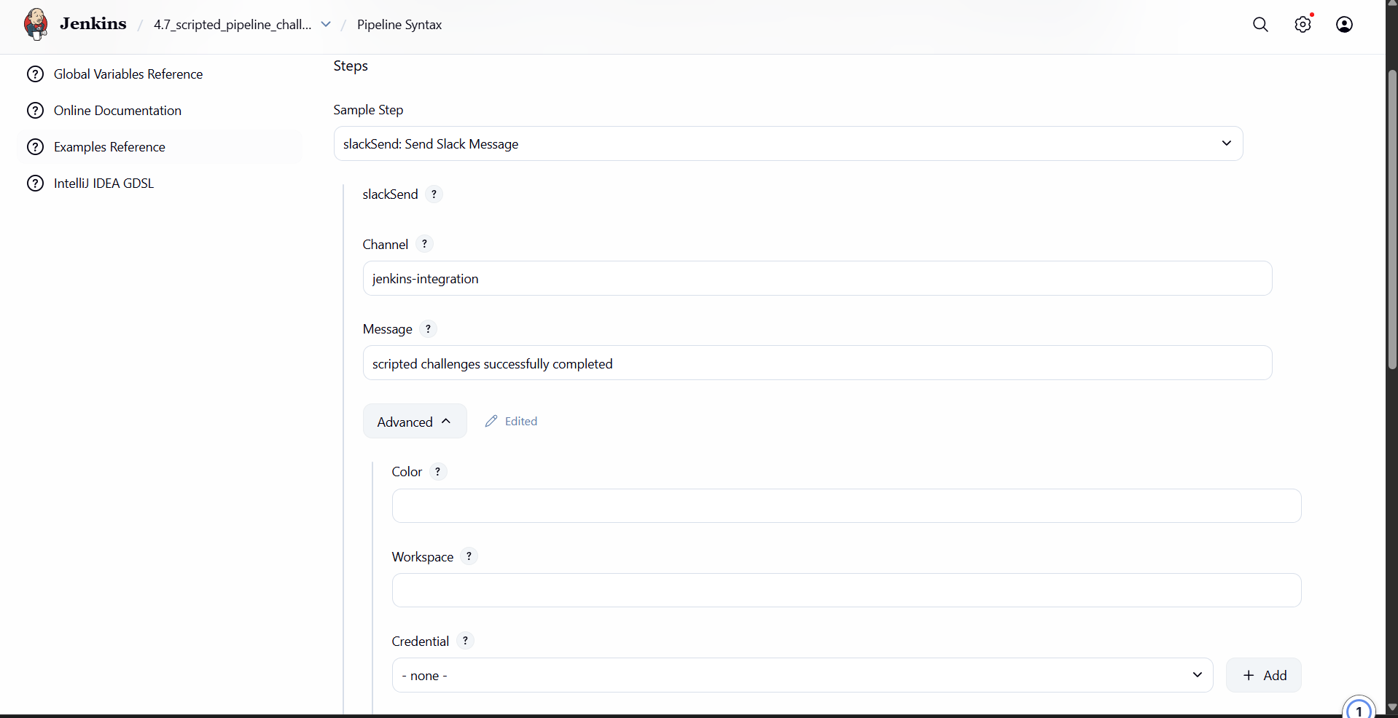
slackSend channel: 'jenkins-integration', message: 'scripted challenges successfully completed ', username: 'BHARATHIRAJA-15'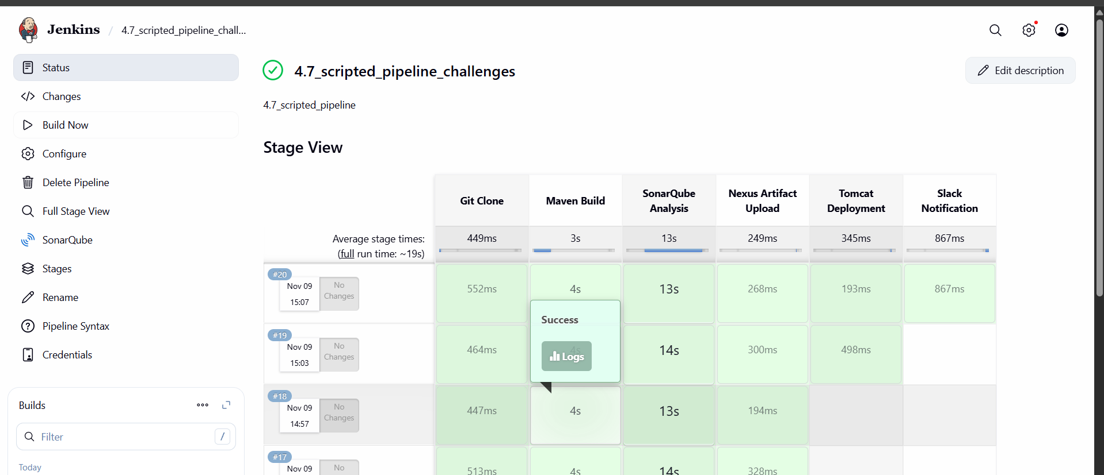
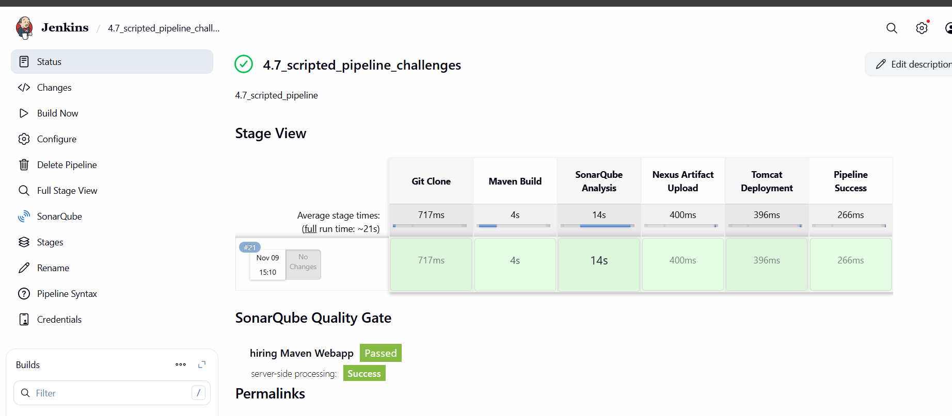

  - Create one multistage pipeline job
Create a new project multistage pipeline
1) High level flow (what we will build)
We’ll create a declarative Pipeline with these sequential stages:
- Clone Code — checkout source from Git
- Build — mvn clean package
- Unit Tests — mvn test
- Package / Archive — archive the produced WAR
- Deploy to Tomcat — deploy WAR to Tomcat server
- Slack Notification — notify success/failure

  - Clone Code — checkout source from Git

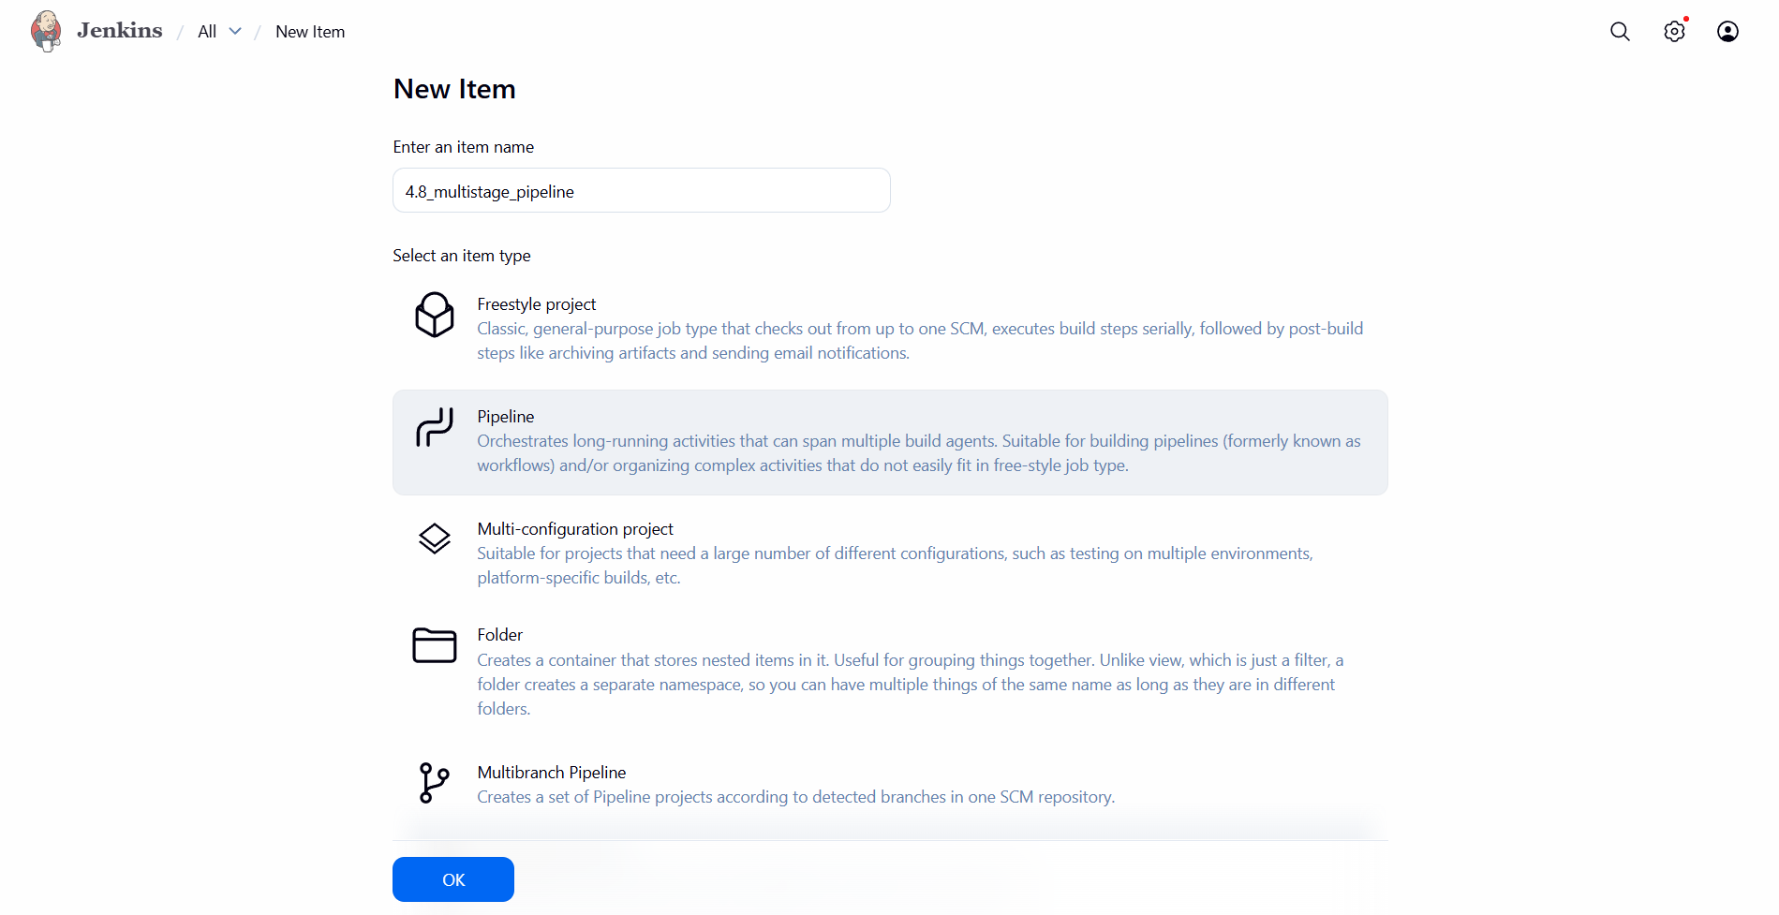
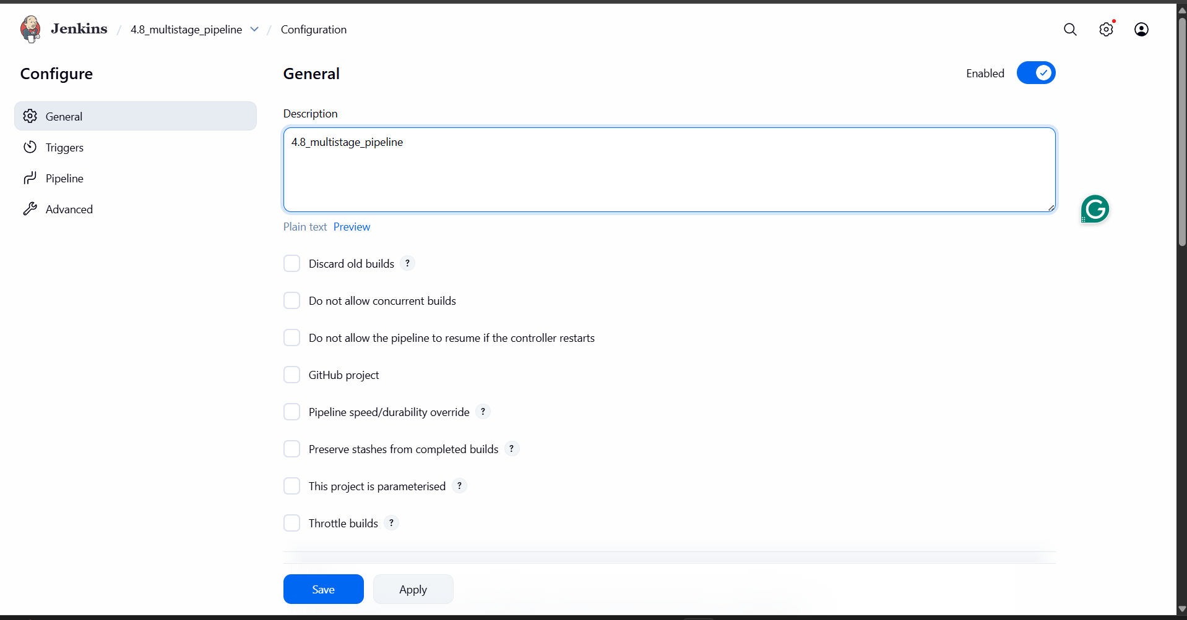

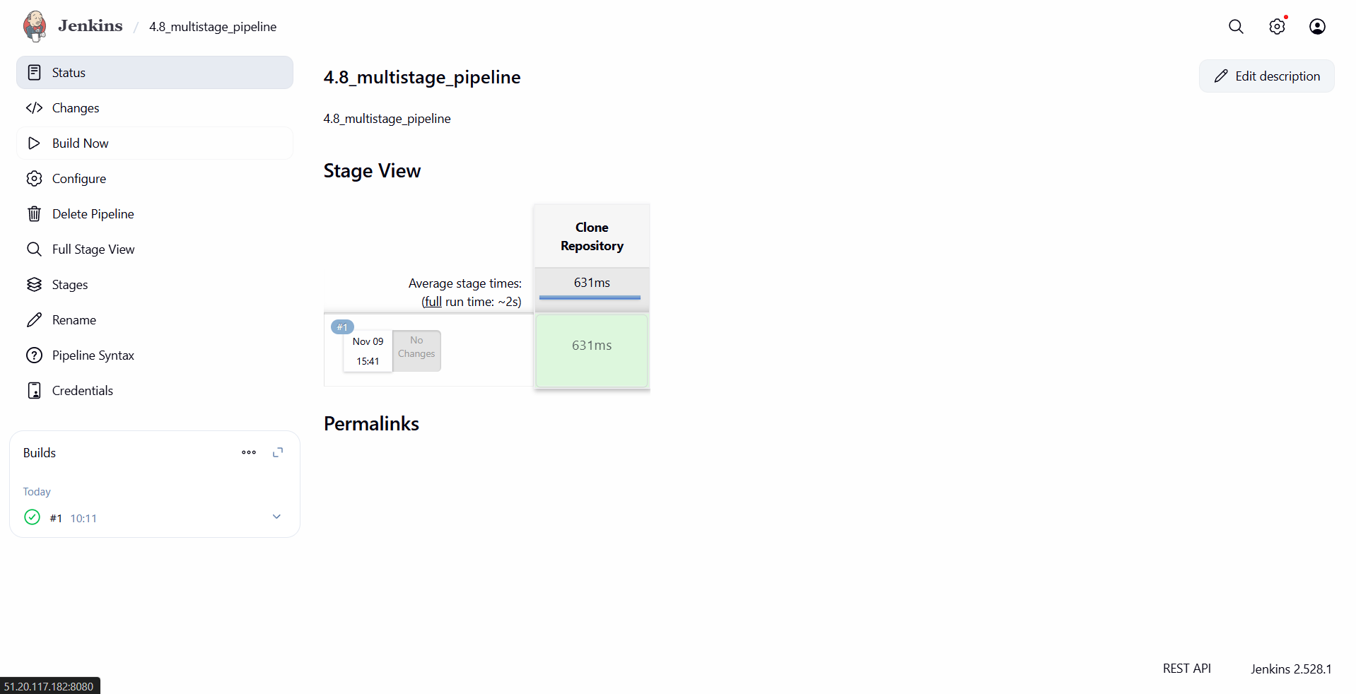
See git clone happen, source code is downloaded
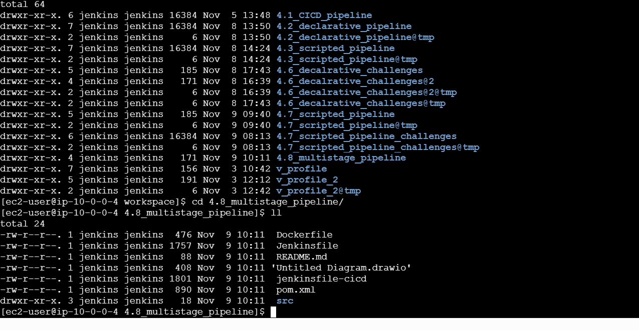
2 ) Maven code
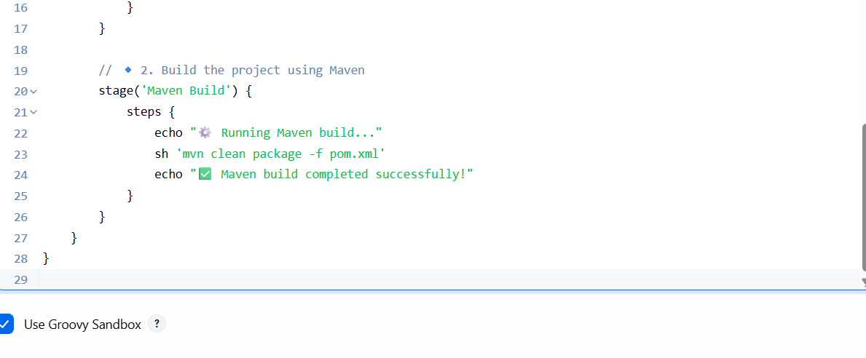
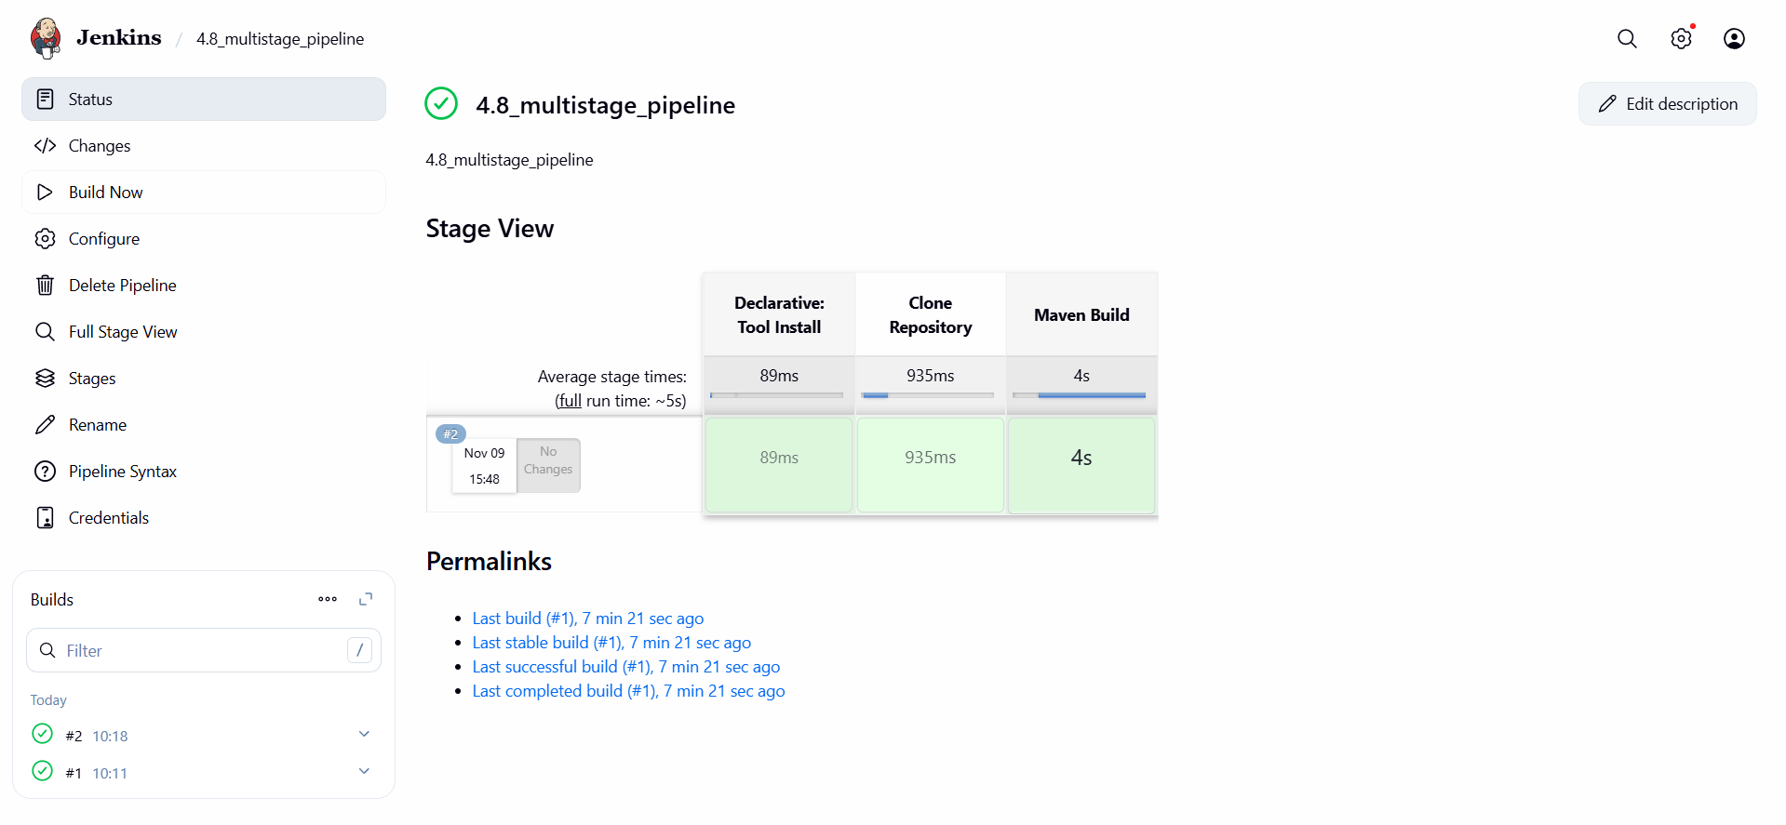

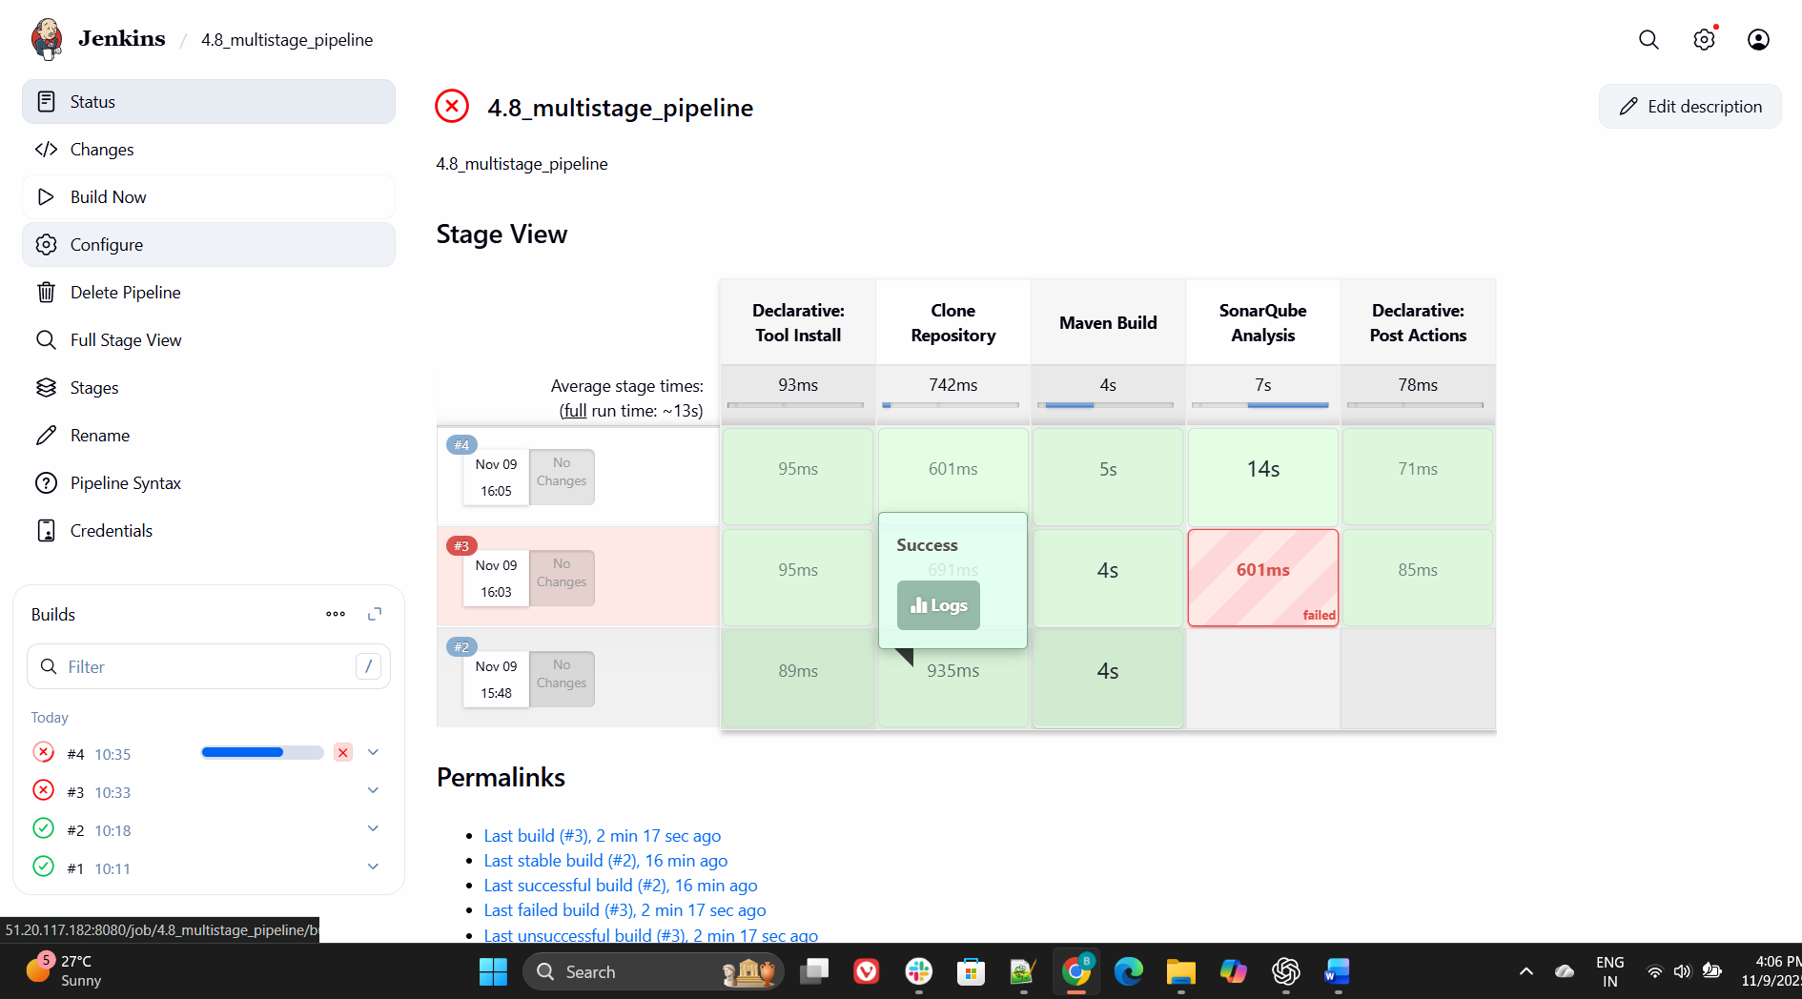
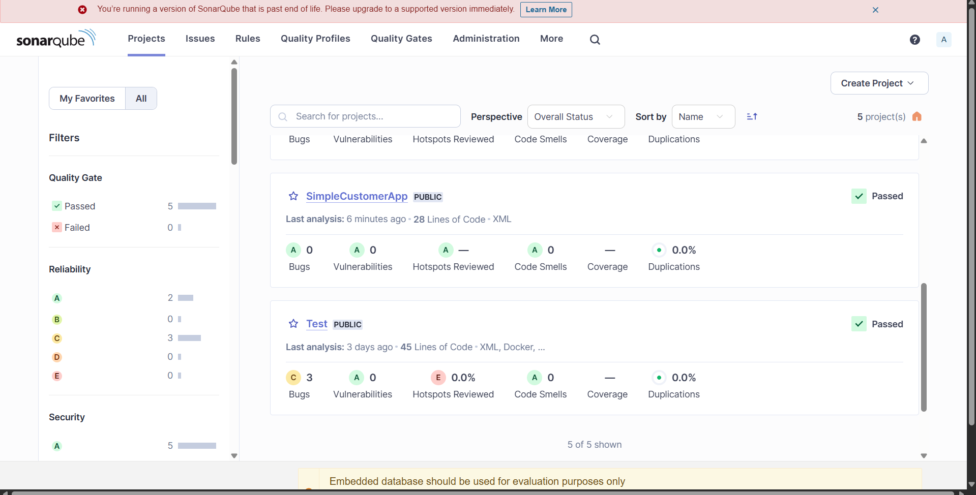
Now finish
Nexus we need give detailes
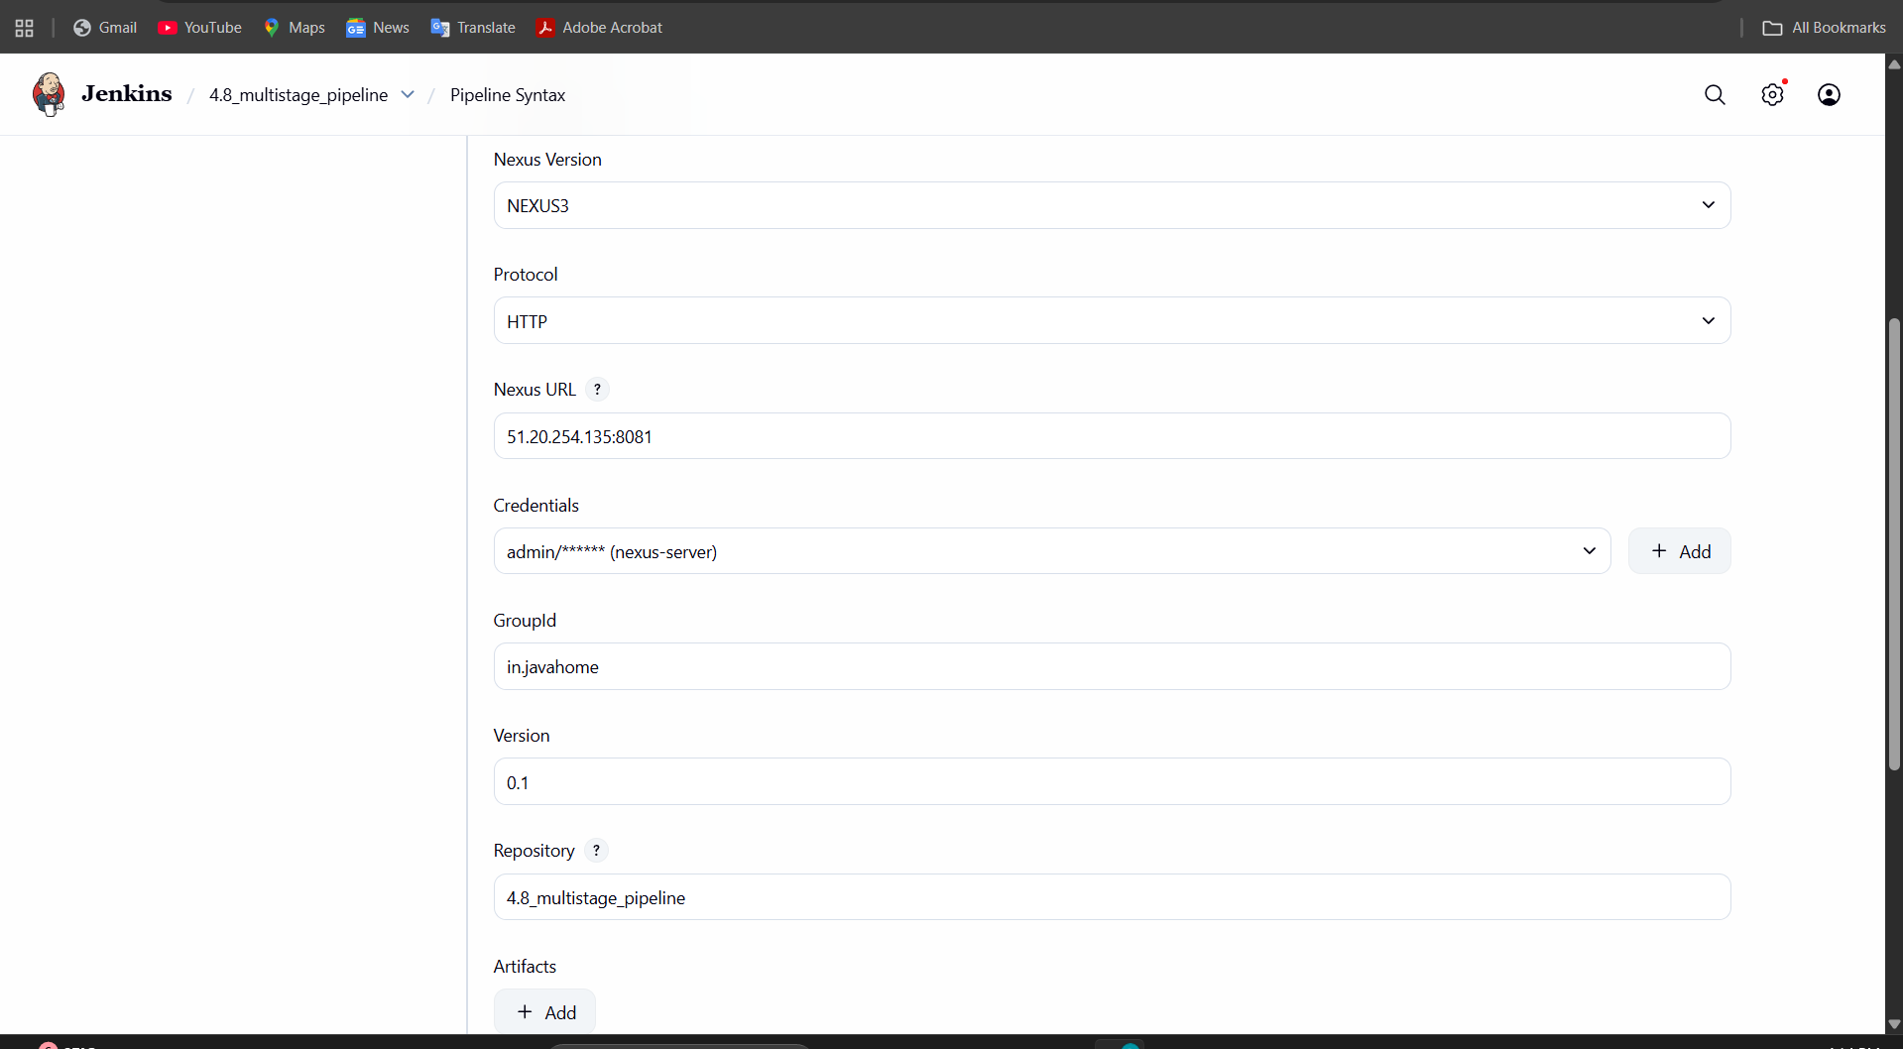
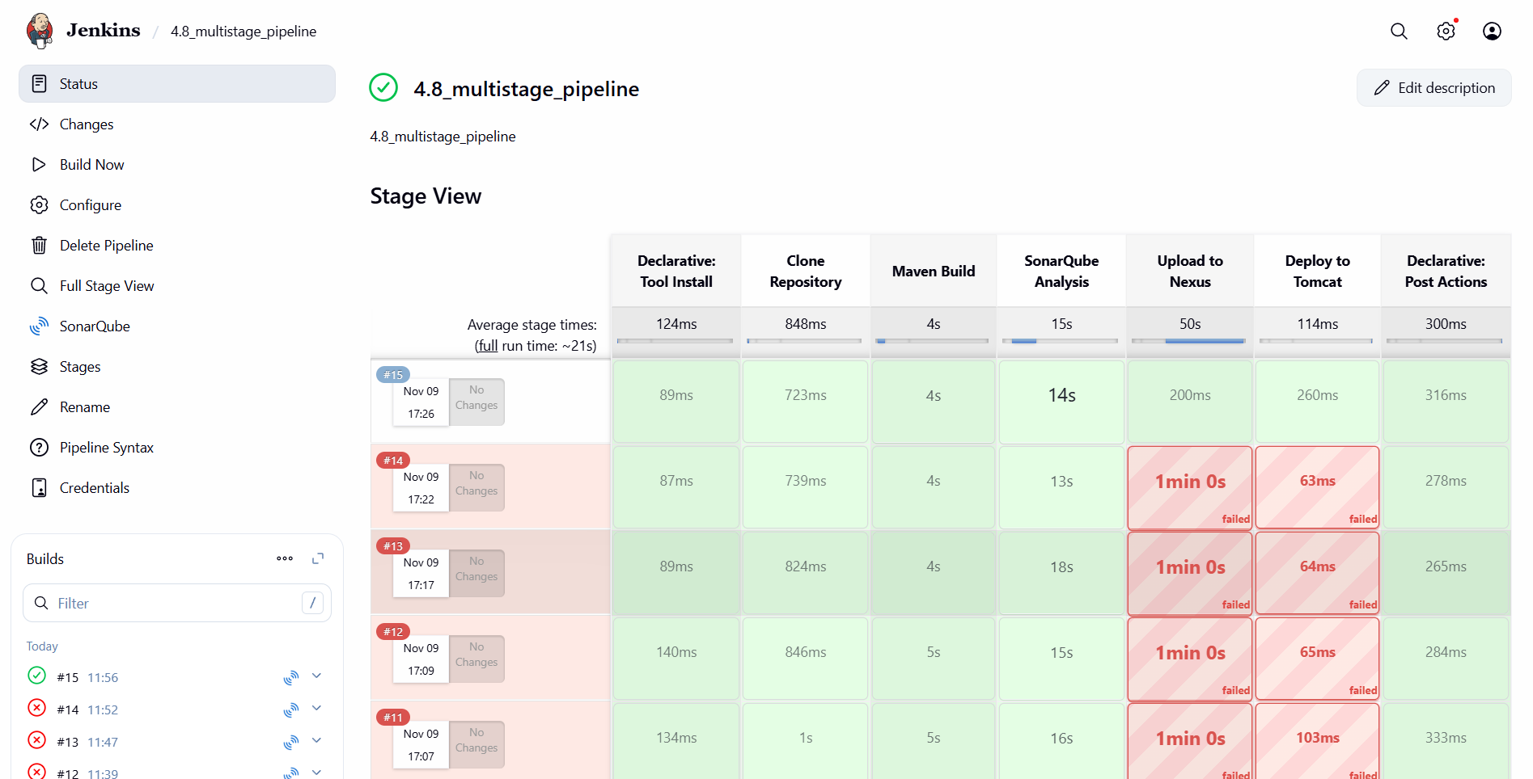
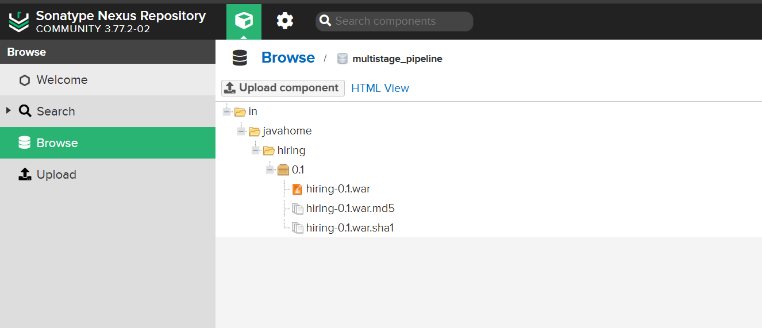
pipeline {
agent any

tools {
maven 'MVN_HOME' // Must match the Maven name configured in Jenkins
}

environment {
// Optional environment variables
SONARQUBE_ENV = 'sonarqube_4.1'
NEXUS_CREDENTIALS = 'nexus-server'
TOMCAT_CREDENTIALS = 'tomcat'
SLACK_CHANNEL = 'jenkins-integration'
SLACK_USER = 'BHARATHIRAJA-15'
}

stages {

// 🔹 1. Clone the source code
stage('Clone Repository') {
steps {
slackSend channel: "${SLACK_CHANNEL}", message: "🚀 Build started: Cloning repository...", username: "${SLACK_USER}"
git branch: 'main', url: 'https://github.com/betawins/hiring-app.git'
}
}

// 🔹 2. Build the project using Maven
stage('Maven Build') {
steps {
slackSend channel: "${SLACK_CHANNEL}", message: "🧱 Running Maven build...", username: "${SLACK_USER}"
sh '''
mvn clean package
mkdir -p target
cp target/hiring.war target/SimpleCustomerApp-${BUILD_NUMBER}-SNAPSHOT.war
'''
}
}

// 🔹 3. Run SonarQube code quality analysis
stage('SonarQube Analysis') {
steps {
slackSend channel: "${SLACK_CHANNEL}", message: "🔍 Running SonarQube analysis...", username: "${SLACK_USER}"
withSonarQubeEnv("${SONARQUBE_ENV}") {
sh 'mvn sonar:sonar'
}
}
}

// 🔹 4. Upload build artifact to Nexus
stage('Upload to Nexus') {
steps {
nexusArtifactUploader(
nexusVersion: 'nexus3',
protocol: 'http',
nexusUrl: '51.20.254.135:8081',
groupId: 'in.javahome',
version: '0.1',
repository: 'multistage_pipeline',
credentialsId: "${NEXUS_CREDENTIALS}",
artifacts: [[
artifactId: 'hiring',
classifier: '',
file: "/var/lib/jenkins/workspace/4.8_multistage_pipeline/target/hiring.war",
type: 'war'
]]
)
}
}

// 🔹 5. Deploy to Tomcat server
stage('Deploy to Tomcat') {
steps {
deploy adapters: [
tomcat9(
credentialsId: "${TOMCAT_CREDENTIALS}",
url: 'http://16.170.143.182:8080',
path: ''
)
],
contextPath: null,
war: '**/*.war'
}
}
}

post {
success {
slackSend channel: "${SLACK_CHANNEL}", message: "✅ The challenges have been successfully completed.", username: "${SLACK_USER}"
}
failure {
slackSend channel: "${SLACK_CHANNEL}", message: "❌ Build failed! Please check Jenkins logs for details.", username: "${SLACK_USER}"
}
}
}

  - Parallel stage
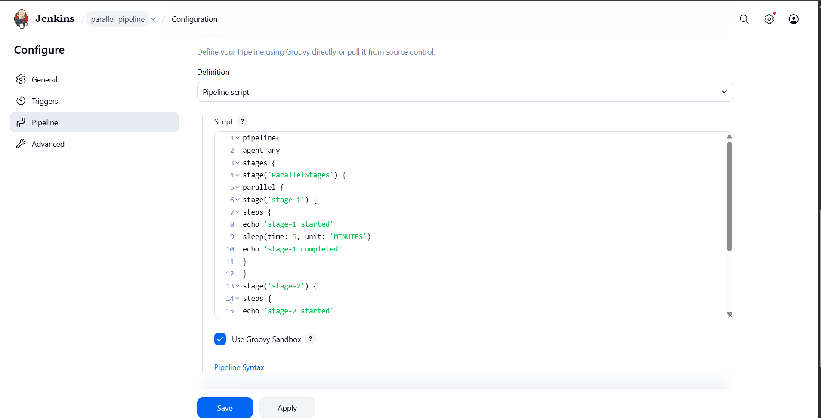
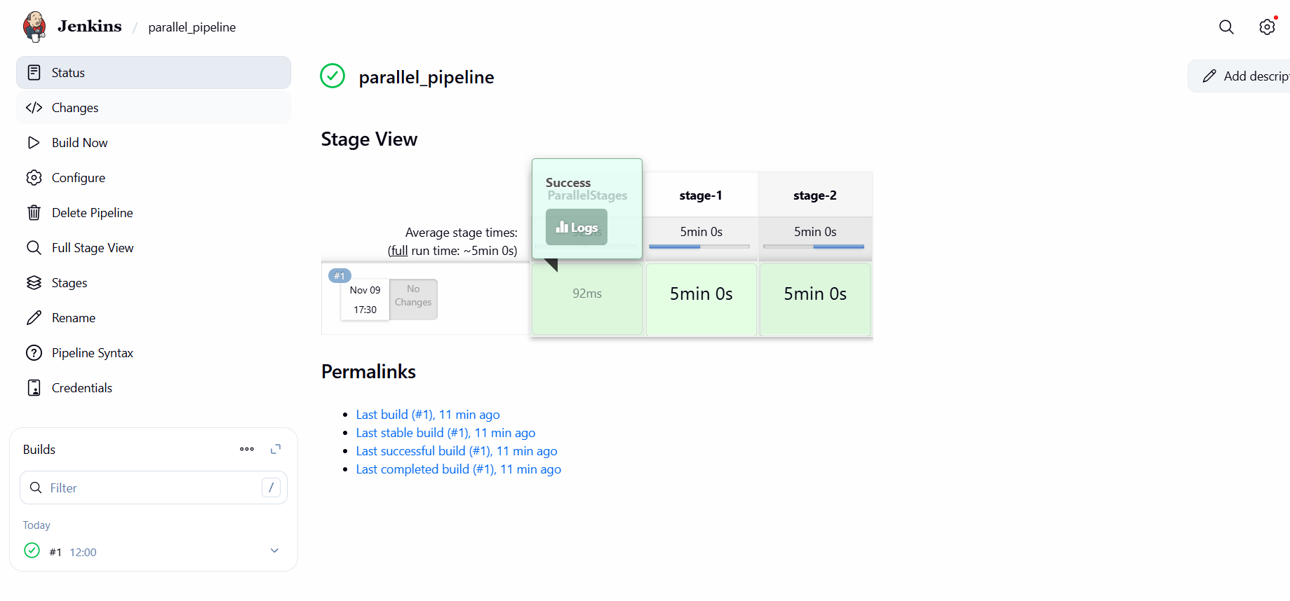
pipeline{
agent any
stages {
stage('ParallelStages') {
parallel {
stage('stage-1') {
steps {
echo 'stage-1 started'
sleep(time: 5, unit: 'MINUTES')
echo 'stage-1 completed'
}
}
stage('stage-2') {
steps {
echo 'stage-2 started'
sleep(time: 5, unit: 'MINUTES')
echo 'stage-2 completed'
}
}
}
}
}
}

